WEEK 1
Retailer Union Tex Fashion Show Production
The main purpose of this paper is to discuss the theme and venue for Retailer Union Tex Fashion show. The paper will entail inspiration images that will illustrate that the show Retailer Union will perform.
Discuss the theme and venue
Fashion show success depends on its theme and the venue. The themes of a fashion production show help in sparking the audience imagination (Johnson 123). It convinces this audience to buy clothes that certain retailer is selling to use for the fashion show. It also provides theatrics, in order to create drama in the performance. Fashion show themes are specialized, interesting, all-encompassing and captivating for the audience. They should also be in tangent with the intent of the show, which can be giving entertainment for some event, designer promoting his collections, and fundraising for charity.
The venue of the fashion show is equally important since it determines the number of participants and audience that will be present in the show. A good fashion show venue should have spacious stage, which the participants will use. It should also have enough lighting for audience, participants and media. In addition to that, it should have good sitting arrangement, which can hold a large audience that can move around freely (Bye 73).

The best venue for the Retailer Union Tex Fashion show
Loft on Lake will hold the show. This venue is in the Near West Side, West Loop in Chicago. The Loft on Lake prepares good stage for the fashion shows. This stage is spacious to allow room for Fashion Show attendees to browse the clothing selection. It has also a good lighting system where the media and other video takers can take the quality video.
The stage of Loft of Lake
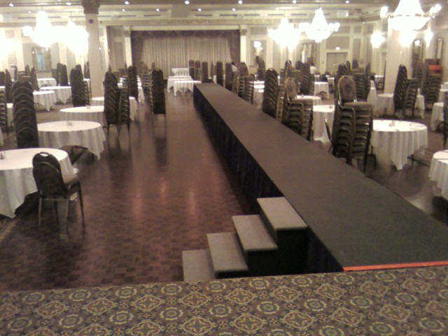

Source: Chicago Business Journal, p. 84
The venue is popular for concerts, society weddings and fashion show functions. This is because it has a magnificent castle, which has a shop that stocks souvenirs, local crafts and a public tea room. There is also ample parking for vehicles. It also has a boating pond where a number of rare indigenous plants grow. Accommodation is of a reasonable standard in terms of cost effectiveness and capacity.

The theme for the fashion show
The theme to be used is high conventional theme. This theme will target the customers who were high quality and casual clothes to ensure maximum sales for the designer. It will depict winter seasonal theme with go green objective derived from inspiration for clothes drawn from haute couture designer outfits. The Retailer Union Tex will use the show theme to promote its designed collections. The show will use substantive cost and quality clothes. Makeup and hair of models should match the designer’s clothes (Seivewright 37).
It will also be used to encourage environmental conservation. The décor plans to integrate to high conventional fashion and eco theme in the show. This will ensure he or she has achieved his or her objective of achieving maximum profits and satisfying his or her customers and society needs. Good sound effects and music will conclude the theme, which will improve the designs set for the fashion show.
Theme inspirational board/college

Inspiration Boards: The Luxurious Eco-Friendly Fashion Show
Green friendly, powerful, high quality casual style fashions show will ensure the audience satisfaction in terms of quality, money worthiness and environmental benefits. This fashion show will be done in December holidays, which is during winter season. This is when the market is in boom and customers have money which could be directed to buy designer’s cloths to use in the fashion show.
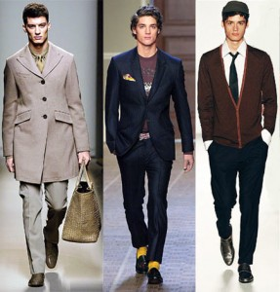
Source: Chicago journal
The show will emphasize on green color cloth collections as the theme. This is to ensure that it caters for the audience who are environmental conscious.
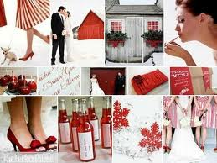

Source: Chicago journal
The show will use high quality casual cloth and fashion show collections. The collections are very expensive. This is since they are luxurious, fashionable and gives a lot of comforts to the users.
WEEK 2
Theme
The theme to be used is high conventional theme. This theme will target the customers who were high quality and casual clothes to ensure maximum sales for the designer. It will depict winter seasonal theme with go green objective derived from inspiration for clothes drawn from haute couture designer outfits (Bye).
The venue
Loft on Lake will hold the show. This venue is in the Near West Side, West Loop in Chicago. The Loft on Lake prepares good stage for the fashion shows. This stage is spacious to allow room for Fashion Show attendees to browse the clothing selection. It has also a good lighting system where the media and other video takers can take the quality video. This fashion show will be done in December holidays, which is during winter season. This is when the market is in boom and customers have money which could be directed to buy designer’s clothes to use in the fashion show.

The retailer and style of clothing
The Retailer Union Tex will use the show theme to promote its designed collections. The show will use substantive cost and quality clothes. Makeup and hair of models should match the designer’s clothes. The show will use casual clothes and green styles to help in sensitizing the audience on environmental protection.
Fact sheet
The audiences have different tastes on different clothes and fashion.
The fashion show involves the use of theatrics to entertain the audience.
The fashion show clothes should be distinct in order to help the audience differentiate them.
The audience evaluates the themes of the fashion show in determining whether they will attend the next shows.
The collections of each designer may be used to evaluate satisfaction of the audience.
The venue determines the number of participants and audience who will attend the show.
Venues that have adequate space have more participants and audience attending them.
Venues with spacious stages create a better view by the audience on the fashion show performances.
Schedule of events
Friday February 7, 2014 8am -9am
Participants and audience arrive at the venue of the fashion show.
9am -10am- the audience will be entertained by many groups before the fashion show commences.
10am -11am
Raising funds for charity
The participants will be equipped with clothes and make ups that will be sold at higher than usual prices to raise money for charity. All the makeup services will be offered at $25 but clothes will be sold at different prices based on their value.
11am-12 noon
Modern fashions group will take the stage to present their new official collections.
12noon-1pm
Smart wear fashions present their models, which are high quality and expensive.
1pm-2pm
All the participants of the fashion show break for lunch.
2pm -5pm other cultural performances by groups from all over the world.
There will be cultural performances from the American groups and others from Asia and Africa. They will perform dressed in their designer collections. The performances will feature music and entertainment.
5pm-6pm
The Retailer Union Tex presents its Green friendly, powerful, high quality casual style collections from its most recent graduates.
6pm-7pm
Cocktail reception
7pm-7.45pm
Selection of the designer of the day
Action plan
Task Time Deadline
Entrance of participants and audience to the fashion show venue | 1 hours | 9am
Entertaining of the audience | 1 hour | 10am
Raising funds for authority | 1 hour | 11am
Modern fashions group presentation | 1 hour | 12noon
Smart wear fashions presentation | 1 hour | 1pm
Lunch break | 1 hour | 2pm
Other groups present presentations | 3 hour | 5pm
The retailer Union Tex presentation | 1 hours | 6pm
Cocktail Reception | 1 hour | 7pm
Voting of Designer of the day | 45 minutes | 7.45pm

Steps needed to produce all events
The fashion shows should be announced or advertised to attract more audience.
The fashion show should sell tickets for people who are willing to attend the show to help them manage the resources such as space and themes or the number of participants.
The managers should monitor the number of audience who are likely to attend the show to arrange for the activities and schedule of the show.
The audience should have some information on the designers and the retailers who will participate in the show in order to make their decision before attending them. This will help in preventing surprises for the audience.
The events that will be held in the show should be placed in their schedule, which may be prepared by a representative of the participants, management and the audience in order to balance their needs.

WEEK 3

Clothing trends
The clothing to be showcased will be placed with the respective hair style and make up trends. Official hairstyle and make-up will go with official clothing. The sporty look and the casual clothing wear will correspond with the hair and make-up trends that suggest a sporty outlook and casualness respectively. This will assist in accessorizing the look and making it look more appealing and complete.
Make-up and hair trends
The hair and make-up trends will also have the differentiation of official hairstyles and make up, casual make-up and hair style trends as well as sporty hairstyle and fashion trends. All these will have to be in line with the environmental theme through the use of color and in some cases the material used to make the make-up, hair products or additions where possible. The environmental friendliness of materials will also be used in the clothing to be showcased. The make-up and hair trends will be important in determining how the models should look like and not vice versa. This is because the hair and make-up trends are unique and have been predetermined. The only important thing is that model scouts will look for models that can accentuate the hair and make up trends. The hair and make-up color pallet will have the following colors available.

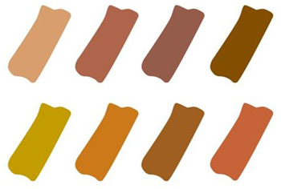

Figure 1: Color Pallet for make up and hair colors
Model selection
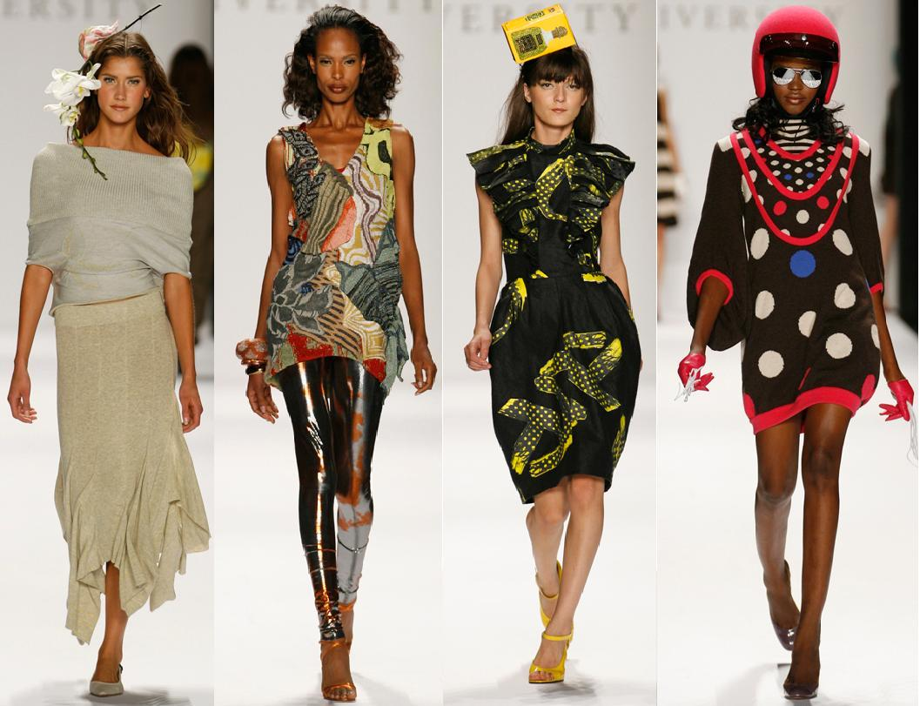
The selection of models is crucial because they will showcase the fashions during the show. The models also showcase the beauty products and hairstyles available and, therefore, model selection will be crucial to the success of the event. To put this into context, it is crucial to understand that different models have different requirements in terms of fashion trends they can showcase as well as hairstyles that can be used on the. For example plus size models will be used to only showcase certain types of clothes and make up, slimmer models will showcase other types of clothes that appeal to an audience that is slim. Therefore, model selection will take cognizance of the items of clothing available for showcasing as well as the theme for the fashion show.

Figure 2: Clothing, makeup and hair style Variety and Model Diversity Source: Fashion Central
The model selection will determine the look of the event, and how receptive the audience will be to the fashion, hairstyles and make up being showcased. The audience targeted is also important in model selection based on their predetermined preferences in terms of male and female models. To accentuate the theme about the environment models with a more environmentally friendly outlook will be used. The diversity of the prospective members of the audience will be reflected as much as possible in model selection. The models to be selected will reflect the diversity of the audience in terms of age, ethnic background, socio-economic background, size and tastes. The hair trend boards and make up will also determine the look of the models. The fashion show will showcase casual clothing options, official wear and sportswear.
Figure 3: Diversity of Models Source: www.thevipconcierge.com
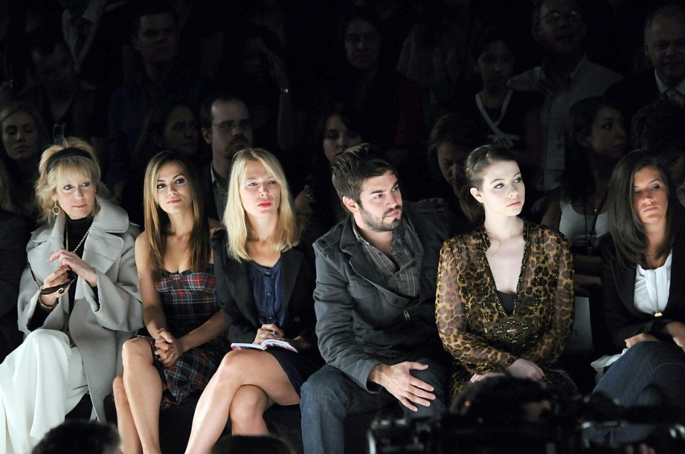
The suggested hair, ensemble looks and make up will appeal to the target audience for this retail line because of a number of reasons. The target audiences are ideally working class populations or people with considerable disposable incomes. They engage in routine working or business schedules mostly which require official or casual dressing and once in a while they may go for vacations or other fun events, and this is where the sporting clothing comes in handy.

Figure 4: Audience Diversity Source: cwww.whedon.info
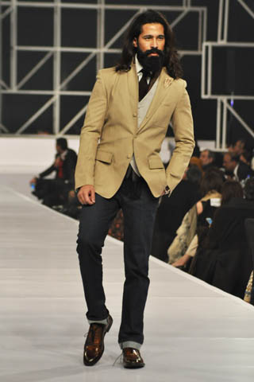
Figure 5: Male Model in Casual Look: Source: www.fashioncentral.pk
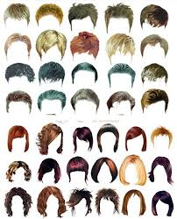
Figure 7: Men’s Hairstyles and Hair Color
The target audience comes in different descriptions and models are essentially going to be used to create a connection between the distinct features and characteristics of the audience. The plus sized models will create the connection and appeal to members of the audience who are plus sized and so will other characteristics of the models including hair and skin color, height and gender be connected with models that have similarities with members of the audience. All varieties of models will be used. The color pallet represents the majority of the intended audiences in terms of hair color and make up preferences.
The images used in the templates seek to show the diversity of models, some of the clothing options available and the diversity of the audience. Figure 5 and 3 showcase the diversity of models. Figure 4 shows the diversity of the audience and figure two shows the clothing options available.

