LESSON PLAN (Individual): 30 %
Due: Week#6
Value: 30%
Write a lesson plan following the guidelines from The Ontario Curriculum Arts document (2009), chapter 16 from Teaching Towards Musical Understanding, and a core subject expectation. You will choose from six songs and write a lesson plan using the template which will be sent via email to you. The assignment must be typewritten/word processed on the template. Appropriate references must be included and properly documented.

Required Reading for Session #4: Montgomery, A.P. (2002) Teaching Towards Musical Understanding. Toronto, On: Pearson Education Canada Inc., pages 29 – 30, Chapter 16 (especially pages 318 – 325). Pages 7, 12, & 13 may also be helpful. It is important that you understand the five different sections of a music lesson.
Songs for Lesson Plan
Due Session #6

This is ONE of the songs below for your lesson plan. You will need to find 5 more appropriate songs to go with the lesson and the grade 1 Ontario Curriculum guidelines

Teaching a New Song/Poem:

There are two different methods for teaching a new song:

1. By sight (note): The students are asked to read the music. Usually you focus on one or two elements, e.g. rhythm is usually first. Then you might ask about the tonic sol-fa syllables

2. By Rote:
  - Question and Answer Method:
- Motivate the students by asking a question about the song, e.g. in the song, Hey Betty Martin, the teacher might ask, “What was Betty Martin doing?” Sing the entire song and then ask the question again?
  - Phrase by Phrase Method
- Use the same method that you used above to motivate the students. You sing one phrase and the class repeats. Sing the second phrase. The class repeats. Sing the first two phrases. Class repeats. Sing third phrase. Class repeats. Sing fourth phrase. Class repeats. Sing third and fourth phrases. Class repeats. Sing the entire song. Listen carefully as the students sing back the phrases to ensure that they are singing properly and to make the appropriate corrections.

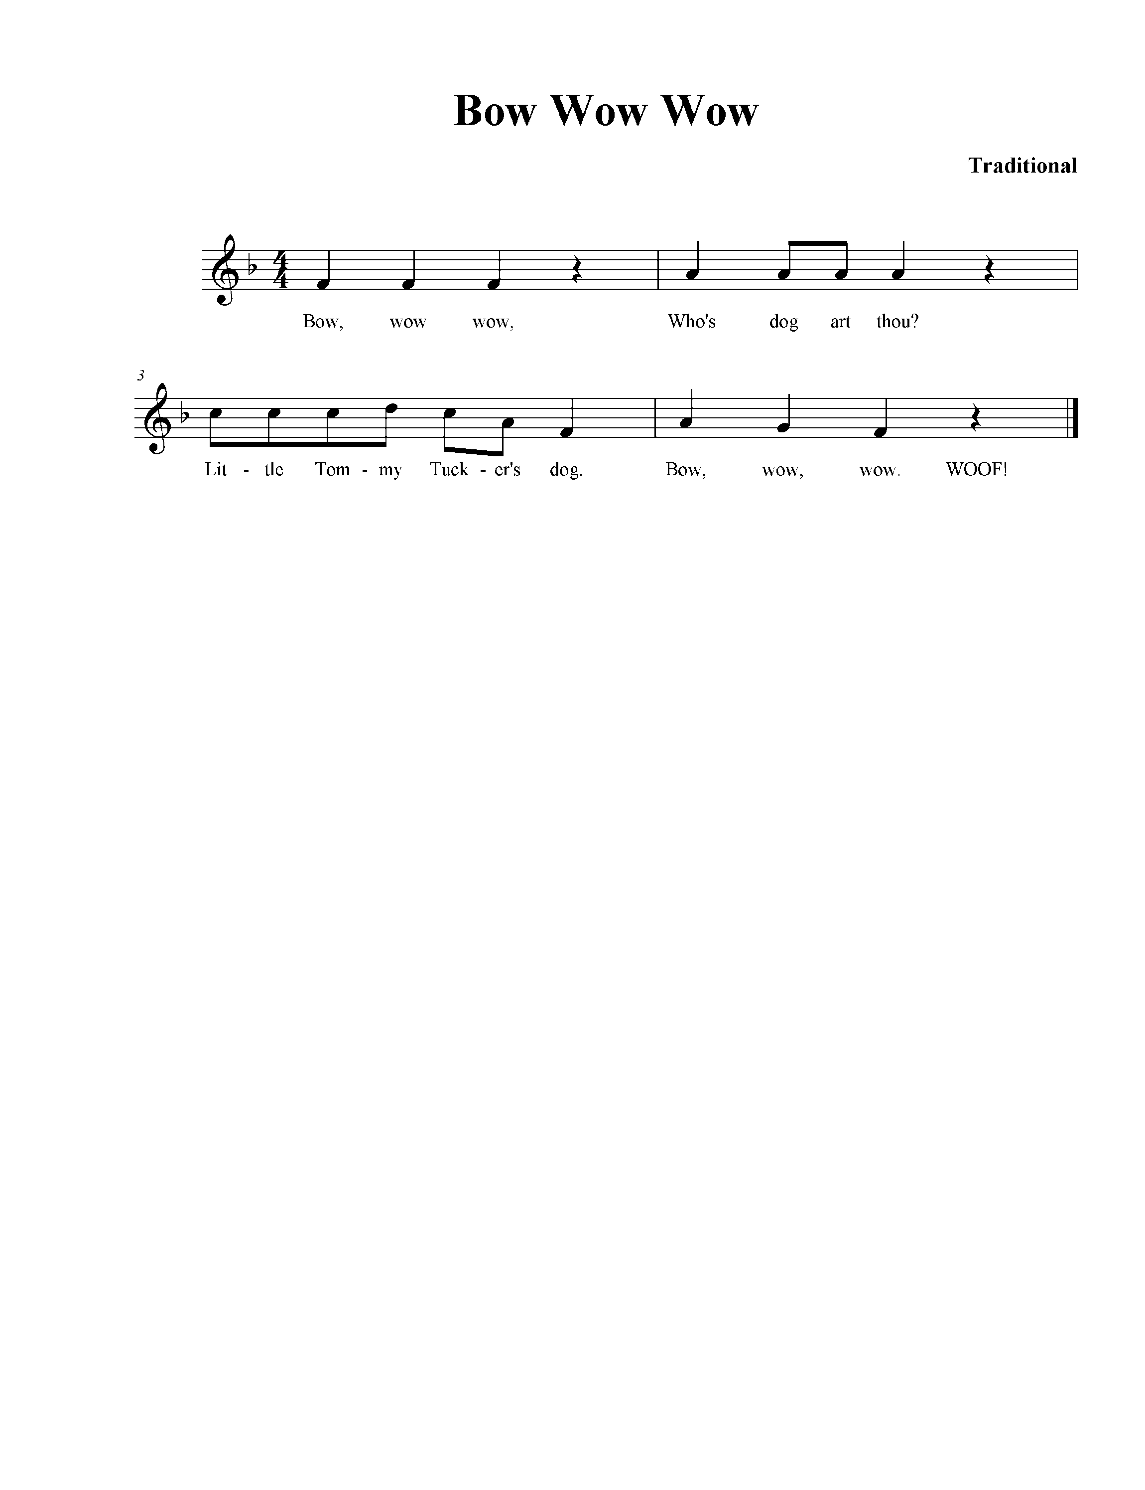

CHART #2

TEACHING A CONCEPT IN A LESSON PLAN

My goal is to teach students to read ____________________ using picture/stick/standard notation.

 | DEFINITION | YOUR LESSON PLAN – GRADE _______
FUNDAMENTAL CONCEPT | Required concept to be taught in a particular grade based on The Ontario Curriculum | Reinforce/Introduce?: ____________________________________
MINDS ON:  - OPENING  - MOTIVATION | - Fun & focus  - Warmup the children’s voices, ears, bodies  - Do NOT teach concept here | Resource: ( e.g. song/game/listening) | Activity:
 | - Do NOT teach concept here  - Experience main concept aurally, orally, and/or kinaesthetically. The students have been doing this for weeks/several classes. NO VISUAL  - Focus towards the main concept | Resource: ( e.g. song/game/listening) | Activity:
ACTION:  - MAIN ACTIVITY  - ACTIVE CHANGE | - Teach/review the song (choice of 2 methods)  - Teach/label the concept/knowledge using the song I gave you – symbol(s), word(s), action(s)  - This is the ONLY place you will use the song I gave you  - Student learns the vocabulary  - Main concept becomes visual/verbal | Resource: (SONG I GAVE YOU!)  ___________________________  My goal is to teach students to read ____________________ using picture/stick/standard notation. | Activity: TEACH OR REVIEW CONCEPT?
 | - Apply the main concept /new knowledge to a NEW situation, e.g. another song that they know well that would work well to reinforce new concept (visual/verbal)  - Do not teach new concepts here  - This is where assessment takes place | Resource: ( e.g. song/game) | Activity:
CONSOLIDATION & CONNECTION:  CLOSURE | - A short review (visual/verbal) of main concept/ new vocabulary | Resource: ( e.g. song/game/listening) | Activity:

RESOURCES FOR LESSON PLANS

www.naxosmusiclibrary.com
login: lakeuniMM
password: lakeuniMM

OMEA: www.omea.on.ca (resources)

TEACHING A CONCEPT: Sound-Before-Symbol Teaching Porcess
Teaching a concept is a four-step process:
As Amanda Montgomery (2002) states:
STEP #1: AURAL, KINESTHETIC, and ORAL – “Musical concepts from the ten musical elements are experienced unconsciously without reference to label or symbol.” (p.15)
STEP #2: LABEL – “Students learn the verbal and visual labelling (names and notational symbols) of musical concepts from the ten elements of music.” (p.15)
STEP #3: REINFORCE/APPLY - “Students gain practice in recognizing labels and/or notational symbols of musical concepts combined with the practice of translating those symbols into meaningful musical response.” (p.15)
STEP #4: CREATE – “Students create new music using the notational symbols of musical concepts in a unique and personal way.” (p.15)
By the time you have finished teaching the main concept and you are ready to evaluate, the students should have experienced it EIGHT different ways:
- singing
- movement
- listening
- reading
- writing
- playing instruments
- improvising
- composing

 | DEFINITION | GRADE 1 LESSON IN TEXT | MARY’S SAMPLE LESSON – Grade 2
FUNDAMENTAL CONCEPT(S) | Required concepts to be taught in a particular grade based on The Ontario Curriculum | Reinforce “ta” and “ti-ti” | Introduce “ta-a”
MINDS ON:  a) OPENING  b) MOTIVATION | - Fun & focus  - Warmup the children’s voices, ears, bodies  - Do NOT teach concept here | Review “Hey Hey”  Group & Individual singing | Favourite song
 | - Do NOT teach concept here  - Experience main concept aurally, orally, and/or kinaesthetically. The students have been doing this for weeks/several classes.  - Focus towards the main concept | Rhyme “Criss Cross”  Chant rhyme, clap & play rhythm, keep the beat | “There was a Little Turtle” – Students are singing, moving and using body percussion (half note)

Musical Concepts Emphasized

Beat: Keeping the beat
- Tempo: fast vs. slow
- Metre:
- Rhythm: half note (ta-a), half rest, whole note (ta-a-a-a), whole rest
- Dynamics: loud vs. soft, gradations in volume, e.g. getting louder (crescendo), getting softer (decrescendo, diminuendo)
- Timbre: classification of instruments by listening to their sound
- Pitch: high vs. low, pentatonic scale ( do-re-mi-so-la)
- Form: phrase, binary (AB) form, verse and chorus
- Harmony & Texture: singing melodic line in unison song with simple accompaniment (homophony), bordun patterns on “do” and “so”
Expressive Elements: smooth (legato) and detached (staccato)

 | Level 4/5:  80% to 100%  (A- to A+)  Indicates work that: | Level 3:  70% to 79%  (B- to B+)  Indicates work that: | Level 2:  60% to 69%  (C- to C+)  Indicates work that: | Level 1:  50% to 59%  (D- to D+)  Indicates work that: | Level 0:  below 50%  (F)  Indicates work that:
Quality | Is exceptional, exemplary, complete, thorough, and comprehensive. | Is complete, thorough, and comprehensive. | Is mainly complete --although not consistent in thoroughness and comprehensiveness, it is nonetheless satisfactory. | Is incomplete or inconsistent in thoroughness and comprehensiveness; only marginally satisfactory. | Is incomplete and, therefore, unsatisfactory.
Lesson Organization | Demonstrates a superb and comprehensive understanding of an effective lesson plan. | Demonstrates a comprehensive understanding of an effective lesson plan . | Demonstrates a satisfactory understanding of an effective lesson plan. | Demonstrates limited understanding of an effective lesson plan. | Demonstrates insufficient understanding of an effective lesson plan.
Application of Knowledge | Demonstrates exceptional ability to integrate and apply knowledge presented, e.g. correct use of music vocabulary. | Demonstrates ability to integrate and apply knowledge presented, e.g. correct use of music vocabulary. | Demonstrates some ability to integrate and apply knowledge presented, e.g. correct use of music vocabulary. | Demonstrates limited ability to integrate and apply knowledge presented, e.g. correct use of music vocabulary. | Demonstrates insufficient ability to integrate and apply knowledge presented, e.g. correct use of music vocabulary written language.
Levels of Engagement | Demonstrates a level of engagement through performing, listening and composing which exceeds expectations. | Demonstrates a level of engagement through performing, listening and composing and meets expectations. | Suggests some level of engagement through performing, listening and composing and meets most expectations. | Suggests minimal engagement through performing, listening and composing and barely meets expectations. | Suggests insufficient engagement.

