***iNTRODUCTION***

* WRITE ABOUT spss
* WRITE ME A PARAGRAPH DESRIBING THE SPSS METHOD THAT WE USED, SAMPLING WAS 100 QUESTIONNAIRE. WE DISTRIBUTED THE QUESTIONNAIRES FOR STUDENTS AND EMPLOYEES IN THE TOURISM FIELD.

Write uner each graph the description keeping the graph

***Gender of people who answered the research questions***

__

write about the graph and description of it, explain the rates

***gender of people who answered the research questions (cross table) comperation***

**Gender * Age Crosstabulation**

Count

|  |  |  |  |  |  |  |
| --- | --- | --- | --- | --- | --- | --- |
|  | | Age | | | | Total |
| 18-23 | 24-29 | 30-40 | 41-50 |
| Gender | Male | 10 | 13 | 21 | 1 | 45 |
| Female | 8 | 20 | 26 | 1 | 55 |
| Total | | 18 | 33 | 47 | 2 | 100 |

Write a brief cooperation between the two

***AGE OF PEOPLE ANSWERED THE RESEARCH QUESTIONS***

__

write about the graph and description of it, explain the rates

***nationality of people who answered the research questions***

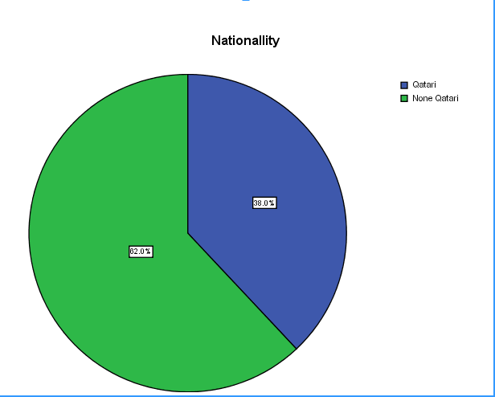

write about the graph and description of it, explain the rates

***occupation of people who answered the research questions***

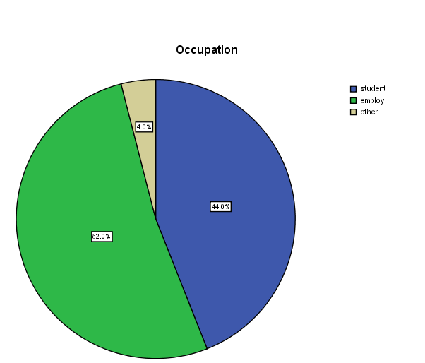

__ write about the graph and description of it, explain the rates

***RATE OVER ALL PLANNING OF THE CONFERENCE: 1STRONGLY AGREE 2AGREE 3SOMEHWTA AGREE 4DISAGREE 5 STRONGLY DISAGREE***

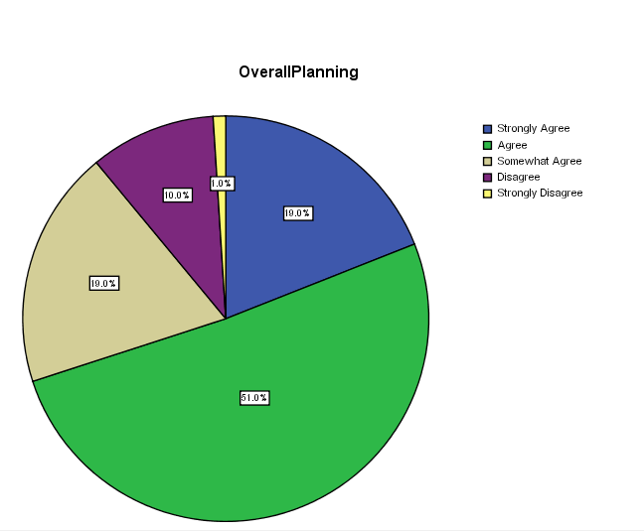

write about the graph and description of it, explain the rates

***OVER ALL CONFERENCE RATING: 1STRONGLY AGREE 2AGREE 3SOMEHWTA AGREE 4DISAGREE 5 STRONGLY DISAGREE***

__

write about the graph and description of it, explain the rates