Instructions:

- The report should not overly emphasize the process that was followed, or the steps taken to complete the work, but more the findings, conclusions and recommendations.
- Use attractive graphics, colour, labels, headings, type fonts - not glitzy, but professional.
- Third person, semi-formal style is required. Avoid first person (I, we).
- Tools and detailed data should be included only in the appendix, but key findings should be highlighted in the appropriate report section
- AND ALWAYS include the evidence that supports your statement (the “how you know this”)

Please include the following tools and/or concepts:
- Four Ps: price, product, promotion, and place
- SWOT
- Porter’s 5 Forces
- PEST
- Strategy Canvas (Blue Ocean Strategy)
- Economic Value to the Customer (EVC)
- Pull Marketing

Please use the following Table of Contents and space guidelines:

Table of Contents:

- Executive Summary (2 pages)
- Introduction (1 page)
- Objective (1 to 2 paragraphs)
- Approach ( 1 to 2 pages)
- Evaluation (as much space as needed)
Services & Segmentation
- The Market (as much space as needed)
- Conclusions (1 to 2 paragraphs)
- Alternatives (1 to 2 paragraphs)
- Recommendations: (as much space as needed)
Targeting, Positioning
Distribution Channels
Pricing
Infrastructure
- References
- Appendix (append the tools)

Please use the following References:

References

- Arcus Healthcare 2020 Report http://www.arcusgroup.ca/future_trends_in_healthcare.htm Excerpt provided below
- Health International. McKinsey & Company Healthcare Systems and Services Practice. Print 2012. Excerpt provided below
- Delivering Value to the Customers. Mc Kinsey Quarterly http://www.mckinsey.com/insights/strategy/delivering_value_to_customers
- Blue Ocean Strategy, W. Chan Kim and Renée Mauborgne, Print. 2005
- The Tipping Point, Malcolm Gladwell. Excerpt provided below.
- Other references as you see fit

Gladwell ‘s The Tipping Point’ p. 19, 67 – 69
According to Gladwell, Mavens start "word-of-mouth epidemics" due to their knowledge, social skills, and ability to communicate. As Malcolm Gladwell states, "Mavens are really information brokers, sharing and trading what they know". Mavens are "information specialists", or "people we rely upon to connect us with new information." They accumulate knowledge, especially about the marketplace, and know how to share it with others

Excerpt from McKinsey Health International
“Behavior change programs can succeed if their design paradigm is rethought – a person-focused paradigm that uses a behaviorally-based rather than a diseas-based orientation to drive sustainable behavior change.
Behaviorally based segmentation, instead of centering on clinical conditions, are more likely to be more successful.“

Excerpt from Arcus Healthcare 2020 Report
“According to Arcus research, 8 million Canadians are Health 2.0 users and fall within the 18-34 age demographic, compared with 3m-4m users in 2007. The Arcus study also found that the younger a user was, the higher the likelihood of going online for healthcare research. A growing divide is the slow pace at which doctors are embracing the medium. The number of people going online to search for health and pharmaceutical information is growing and this demand has yet to be fully addressed.

A shift from treatment of medical problems to disease prevention

At present, our system emphasizes treatment of medical problems, rather than on disease prevention. Healthcare in Canada is an issue that has been hotly debated by both governments and Canadians. At present, our system emphasizes treatment of medical problems, rather than on disease prevention and health maintenance.

This system, however, is very expensive; producing cost increases in healthcare that are well above the average increases in income. While this debate continues, other trends in health care are becoming apparent. For one thing, there will be a growing market for products and services that promote good health. In addition, there is an increasing demand for medical products and procedures that will enable us to look younger. Poor nutritional habits have plagued Canadians for the past several decades, and have resulted in a significant increase in obesity; especially among children.

Another growing trend has been on the increased reliance of cosmetic surgery in improving one's physical appearance. Services for healthy living will be in greater demand as Baby Boomers and Generation X members grow older. As life expectancy increases, the demandfor nursing and rehabilitation services will continue to grow. The nursing shortage that already exists is expected to worsen in the next twenty years.

More also needs to be done to combat diabetes, which now affects more than 2 million Canadians (or 1 in 11 adults). The Diabetes in Canada Evaluation (DICE) study found that nearly half of diabetes patients do not have their blood sugar levels under control. The Health Council of Canada found that half of all family physicians are not well prepared to handle patients with multiple chronic health conditions.

In 2005, the federal government committed $300 million over five years to the Integrated Strategy on Healthy Living and Chronic Disease. Its target is a 20 per cent increase by 2015 in the number of Canadians who are physically active, follow healthy diets, and achieve a healthy body weight. With targets now set, governments and partner organizations need to devise mechanisms for tracking and reporting on progress toward the national targets. “

Background Information (please do not copy as is, but re-write. Feel free to adjust and make changes as seen fit):

EXECUTIVE SUMMARY

The Executive Summary, at two pages max, must include all the important content, summarized.
The Exec Summary is NOT the Introduction to the paper/report.

INTRODUCTION

Describe the company, history, industry, size, or the other important aspects of the organization, their situation, challenges, goals, etc.

Medical Center A in Toronto, ON is a muscoskeletal clinic founded by Dr.E in July 2013. Dr. E also founded the Sports Clinic B back in 2012. Since 2013 both Medical Center A and Sports Clinic B operate in partnership with Laser & Cosmetics Clinic C. Sports Clinic B includes a gym. Although the business model is based on a commercial partnership, the entities have very little operational integration and no common marketing platform. Under the leadership of Dr.E, 20 self-employed professionals (medical and non-medical) work together to make the combined Unit a success. Currently not all the units are profitable.

Some of services offered:
Medical Center A: Orthopedic consults, Pain Management, Sports Medicine
Sports Clinic B: Physical Rehabilitation, Nutrition, Naturopathy, Homeopathy, Mind-Body Yoga, Personal Training, Chiro-practice, Massage Therapy
Laser & Cosmetics Clinic C: Diet & Weight Loss, Cheek Augmentation, Botox, Cosmetic Filler, Laser procedures

Mission Statement: To be the leaders in education and the destination for clients and primary health professionals, where they will learn, engage, grow and advance better health for all.

OBJECTIVE

Although the business model is based on a commercial partnership, the entities have very little operational integration and no common marketing platform. The focus of this project is marketing from a strategy consulting aspect including current state assessment, environmental analysis, branding, integration, promotional activities and recommended management action plan. The desired outcome is a holistic marketing platform integrating all services, incentivizing cross-referrals and becoming profitable.

APPROACH

Gathered some information through:
- phone or personal interviews Conducted interviews with Doctors, Physical Therapists, Chiropractors, Experts, Peers with Experience
- site visits at the clinic and participated in team meetings
- Primary market research on weight loss programs and personal training options in Toronto
- Secondary Market Research through Arcus, McKinsey Healthcare, etc

PRACTICE EVALUATION

(Use statements such as “The interviews showed that…”, “The site observations were consistent in …”, “The market data outlined…”) Include a brief analytical comment with each major finding. It is often acceptable to use some elements of point-form format to describe action steps taken. Detailed data should be included only in an appendix, but key findings should be highlighted in the appropriate report section.

Key Program highlights:

  - Weight Loss Program
Front line professional who see general population with health problems connected to overweight lead to the research for an optimal scientifically proven treatment. Unfortunately, it is not good enough to tell patient “Go and loose weight”. One needs professional guidance, discipline and lots of support.

• Medically supervised 12 week program
• Medical Assessment with Blood work done regularly
• Personalized diet and nutrition plan through Ideal Protein
• Weekly physician consulting
• Groups of 3 and 4

  - MedABC Personal Training
The evolution of personal training and fitness.
All encompassing evaluations (postural, behavioral,
Acknowledges bio-mechanical and muscular diversity
Medically supervised

- Wide variety of applications
  - Executive Training
    - Body awareness
    - injury prevention
    - posture
    - Shorter workouts
    - Professional supervision
  - Injury Rehabilitative Training
    - Therapeutic as opposed to general bio-mechanic and muscle function/repair
  - Athletic Training
    - Advanced Reaction Training
    - Contest preparation
    - High performance nutrition

Allows trainers to:
  - Choose appropriate exercises
  - Sequence exercises correctly
  - Choose appropriate repetition and muscle contraction range

  - Executive Health – comprehensive medical assessment.

Full list of current and prospective services is found in the Appendix.

THE MARKET

Practice Competitive Analysis Observations:
- Porter’s 5 Forces model assessment (draft in Appendix)
- PEST analysis (include in Appendix)

Weight Loss Market Comparison
Practice | Approach | Product Offer | Price Point | Support System
MedABC | In-clinic | Ideal Protein |  | Meditation/Yoga  Option to package with Executive Personal Training
Dr. Sloan | In-clinic | Ideal Protein | $500 / month
Dr. Brown | In-clinic | Do it Yourself Recipes
Dr. Bernstein | In-clinic | Do it Yourself Recipes | $600 / month | Psychological Convincing

MedABC Personal Training Competitive analysis:
Competitors offer GENERALIZED Personal TRAINING.
  - Approaches training on a macro level
  - Fails to acknowledge the micro differences between clients
    - Limb ratios
    - Muscle/tendon insertions
    - Nutritional need differences
    - Training to adjust muscle proportions in body structure

CONCLUSIONS

Draft Segmentation:
- Executives living or working downtown Toronto, busy lifestyle, interested in a holistic healthcare approach including full health assessment
  - Women – living or working downtown Toronto, ages 35-50 interested in weight loss and physical training/toning

- Weekend Warriors – living or working downtown Toronto, minor Injury patients who don’t exercise regularly but overdo it randomly and need therapeutic RMT, Chiro, Physio, etc.
- Patients - Serious Pathology looking for physical rehabilitative services
- Athletes – interested in the more specialized programs of MedABC Personal Training

ALTERNATIVES

Estimate of costs and benefits should be included in this section. The more data here, the better.
Outline pros and cons for each alternative.

Possible Alternative 1
- Not launching a new MedABC brand but marketing the new programs under existing Medical Center A. Avoid the marketing costs of a face lift (logo design, website development, new print marketing material). Risk not being perceived differently.
Possible Alternative 2
- Launching a new MedABC brand but marketing individual services instead of the new programs / packages. This means continuing with the old disease/condition-based approach of the past 9 months. Incurring additional cost of marketing (logo design, website development, new print material) but results might lack in providing the desired outcome. This would only be a superficial façade lift.
Possible Alternative 3
- Do nothing, because the existing set-up of individual services and current Medical Center A branding has not been given enough time to show results. Avoid any of the costs related to a new brand or the marketing infrastructure actions recommended below. Hoping profitability will come, without doing anything is utopia. There is competition in the sports medicine, weight loss, physical trainings areas in downtown Toronto. Without communicating our value differentiator this is just another medical practice with a gym.

RECOMMENDATIONS

Outline the specific action, the person responsible, the target time and the needed budget.
Be as specific as you can be as to your suggested action steps, with as much budget and timeline supporting information.. The person responsible is a must. Give them a road-map that they can follow.

Strategy: Capitalize on the niche market need for specialized expertise.

Launch a new brand that emphasizes medical expertise by having the word medical in its name. The brand is MedABC. Brand Slogan is My Health, Your Health, Our Health. The new brand will provide a facelift to the service offering repositioning it within a niche segment.
MedABC elite promoting health under medical supervision by:
- Educating patients and health professionals
  - Family doctors: Continuing Medical Education (CME) and Continuing Educational Unit (CEU)
  - Patients: postural awareness, corrective exercise
- Personal Injury therapeutic programs
- Weight management
- Body sculpting/toning while promoting health
Focus on education as a primary value communicator for other healthcare professionals.
Focus on key programs targetting behaviors. “ A person-focused paradigm that uses a behaviorally-based rather than a disease -based orientation to drive sustainable behavior change” (excerpt from McKinsey Quarterly in References”)

Retire Medical Center A as an individual marketing unit.
Sports Clinic B: Space and nature of the gym does not target memberships. Patients / Customers will exercise under the supervision of a specialized personal trainer according to the M

Positioning Statement

For [TARGET MARKET],
the [BRAND] is the [POINT OF DIFFERENCE]
among all [FRAME OF REFERENCE]

Distribution Channels

- Family Doctors
- Personal Injury Lawyers
- Corporations for Executive Health Programs
- WWW (see excerpt in References for use of Health 2.0 – online)
- Mavens (see excerpt in References from Malcolm Gladwell’s The Tipping Point)
Utilize Pull Marketing to generate awareness of MedABC:
- Family Doctors want the best for their patients. They care about their reputation as health care professionals so they need to be well aware of the benefits of MedABC before referring patients. Family doctors are not business and marketing driven, so an appeal to their sense of patient care is most appropriate. Family doctors are busy professionals so MedABC can appeal to their interest for development by offering lectures, seminars providing Continuing Medical Education (CME) or Continuing Education Units (CEU).
- Personal Injury Lawyers are business driven. They care for Medical File Reviews for personal injury cases. Built credibility and reputation with Lawyers by being easy to do business with through complimentary file reviews and preferential payment terms for other medical legal services.
- Corporations want one-stop-shop for the Executive Health Assessments and employee wellbeing.
- Engaging blogging, videos and website will position MedABC to the general public as the expert of choice with regards to Sports Medicine, Weight Loss, Personal Training, Executive Health….etc
- Mavens will be invited to our talks and be informally allowed the benefit of complimentary first trial of the new programs.

Pricing
Medical prices are established according to the guidelines of Schedule of Benefits for Physician Services under the Health Insurance Act from the Ontario Ministry of Health and Long-Term Care.
Non-medical

Non-Medical Pricing - Use the Economic Value to the Customer (EVC) approach focusing on the customer and how the customer perceives the value of a programs. With this view, the purpose of price is not to recover costs, but to capture the perceived value for the product in the mind of the customer.

Infrastructure
- Talks and Lunch & Learns. Hold talks every Tuesday with speakers from different fields of life to attract a broad range of audience. The objective is to generate awareness on MedABC care, fitness and rehabilitative programs through unique talks from inspiring entrepreneurs or social trendsetters. A concept made famous in Europe through the ‘Oxygen Bar’ term where a pure interest in O₂ is what brings crowds together to share and educate. Continuing Education Units (CEUs) for physicians
- Brochures, Newsletters, Posters, Signs, banners
- Digital Marketing
- Online marketing (blogs, success stories, case studies, podcast series). The new website will be optimized for mobile viewing.
- People are more interested to experience services than to read about them. Develop videos educating on the fitness mistakes, healthcare myths for patients.
- Write regular Blogs on latest healthcare issues relating to pain management, sports medicine, weight loss, proper exercise and injury prevention, etc. Blogging will engage readers.
- Search engine optimization through use of Google’s Adwords. Google ranking may be affected by reviews and public sentiment to rank websites. Online reputation and integrity is the goal. Encourage reviews and provide regular response on Yelp, Zagat, etc
- Make the website an authority, a widely recognized leader in sports medicine.
- Google Places: claim the address (geo-tagged photos, my maps) and become a downtown landmark.

APPENDIX

This is where all the supporting information should go, organized in the same sequence as mentioned in the report and presented in an attractive and easy-to-use format. These may include specifics of the:

- Industry Competitive Analysis;
- Competitive Product Analysis;
- Market Research;
- SWOT Analysis;
- PEST Analysis;
- Porter’s 5 Forces;
- Strategic Analysis;
- Company Brochures and Literature;
- Maps and Photos;
- Implementation plan

SWOT
Opportunities  Programs targeting niche markets  CME – Continuing Medical Education  CEU – Continuing Education Units  Promote the location as Steps from ‘The Path’ in downtown Toronto | Threats  Other Sport Clinics in downtown Toronto  Other Executive Health Clinics in downtown Toronto
Strengths  Medical Supervision  Staff—Medical/Non-Medical Collaboration  Comprehensive Services | Weaknesses  Location: 0.8km from nearest subway station

Key Programs | Demographics | Income | Lifestyle
Weight Loss Program | 60% - Women  40% - Men  Age group: 30 - 50 | Medium to high income $80 – $120K annual | Little no activity
MedABC Personal Training |  |  | Moderate Activity
Executive Health | Age group 30+ | Medium to high income $80 – $120K annual

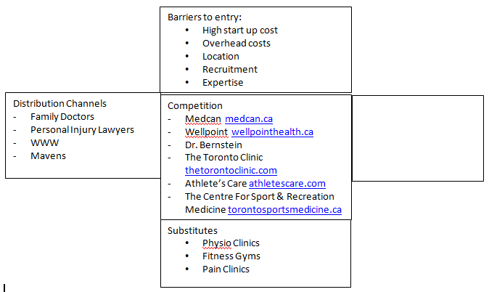

Strategy Canvas Ideas:
Propelling MedABC to action by reorienting focus from competitors to alternatives and from customers to noncustomers:

X Axis for the Graph: Location, Expertise, Program Customization, Price,
- Comparative to respective competition, the goal is to rank all programs HIGHER in Program Customization.
- Comparative to respective competition, the goal is to rank Personal Training program HIGHER in Expertise.
- Comparative to respective competition the goal is to rank all other programs at-PAR on Expertise.
- Comparative to respective competition, all programs rate LOWER on Location.
- Comparative to respective competition all programs rate at-PAR on Price.

As-IS Comprehensive List of Services:

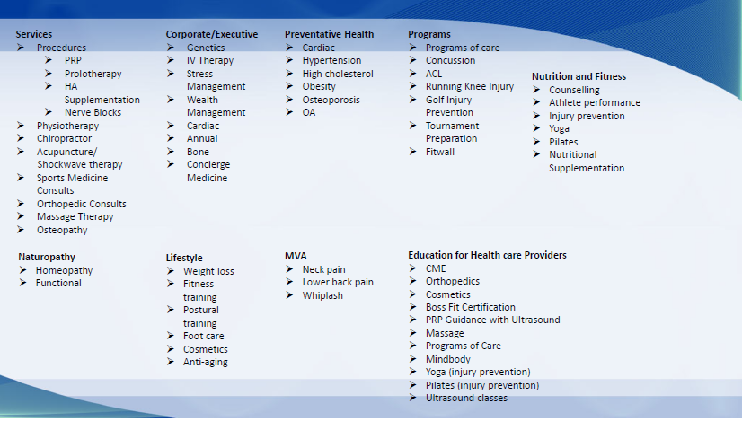

Draft Implementation Plan
 | Month 1 | Month 2 | Month 3 | Month 4 | Month 5 | Month 6 | Month 7 | Month 8
Marketing Strategy Development
Branding Strategy & Implementation
Digital Strategy Development
Pricing Development
Marketing Infrastructure Implementation:  - Action A  - Action B  - Action C |  | - Logo design  - Website development and launch  - Social Media activity launch  - Print Marketing (collateral, brochures, cards)  - Social Talks launch  - Visits to Family Doctors and Injury Lawyers

