A Comparative Analysis of Deck Repair Methods

by

Lily Pond
English 132 Student

for

Dr. Stahnke
Technical Writing Instructor
Milwaukee School of Engineering
Milwaukee, Wisconsin

February 19, 2010

Letter of Transmittal

Feb. 19, 2010

210 Amoeba St.
Croaker, Illinois 60251

Dr. Stahnke
MSOE
General Studies Dept.
1025 N. Broadway
Milwaukee, WI 53202

Dear Dr. Stahnke:

Here is my comparative analysis of different repair methods for Mr. Pond’s deck. In amassing all the information for this report, I recognized how important proper deck maintenance is.

A deck is an appealing extension to any home that should provide a great place to relax and entertain guests. Decks are constructed from a variety of materials such as: treated lumber, aluminum, and composite materials like vinyl. The most popular choice of material in decking is wood because it is stable, durable, easy to work with, and the most economical.
The primary complications I experienced when writing this report occurred when I was gathering research. It was difficult to find pricing on cedar two by six boards online that were necessary for the repairs. I overcame this obstacle by calling a lumber distributor, home depot, and getting the pricing for boards from a member of their lumber department.
Thank you for giving me the opportunity to pursue this topic as it allowed me to help my father deal with an issue that he hasn’t had the time to properly address.
Sincerely,

Lily Pond
Table of Contents
Letter of Transmittal ii
Table of Figures iv
Abstract v
Data Section 1
Introduction 1
The Condition of the Deck 1
Client’s Needs 2
Different Flooring Materials 2
Wood 3
Cedar 3
Pressure Treated Pine 3
Aluminum 3
Vinyl 4
Client’s Decision 4
Estimated Cost 4
Build Material 4
Weather-proofing Solution 5
Summary 6
Recommendations 7
Work Cited 9
Work Consulted 9

Table of Figures

Figure 1. Mr. Pond’s Deck Frame……………………………………………………………….2

Figure 2. Rotten Floor Boards…………………………………………………………………….2

Figure 3. A Cedar Deck…………………………………………………………………………..3

Figure 4. A Pressure Treated Pine Deck………………………………………………………….3

Figure 5. An Aluminum Deck…………………………………………………………………….3

Figure 6. A Vinyl Deck…………………………………………………………………………...4

Figure 7. Over head view of the deck…………………………………………………………….5

Figure 8. Split level view of the deck…………………………………………………………….5

Table 1. Repair Costs……………………………………………………………………………..7

Table 2. Maintenance Costs………………………………………………………………………7

Abstract
This report is a comparative analysis of deck repair methods for repairing Mr. Pond’s deck. The 22 year old deck has rotten floorboards that need to be replaced because they pose a danger of collapsing under pressure and causing personal injury to Mr. Pond and his family. He needs to find the best approach to repair his deck for the minimum cost. Information for this report was gathered from personal interviews with the client, an interview with an expert of deck stain from Benjamin Moore, on-site observations and measurements, internet sites pertaining to the build materials, Home Depot, and personal knowledge.

After inspecting Mr. Pond’s deck, no other major problems were evident. The only repair required will be replacing the rotten floorboards. Mr. Pond’s deck will not need to be completely rebuilt. The data pertaining to the four options Mr. Pond has for flooring led him to choose cedar as his build material over pressure treated pine, aluminum, and vinyl because he wants to keep his deck constructed out of wood, he likes the smell of it, and it fits his budget of $3000 the best. To protect his investment, Mr. Pond will need to choose the correct weather-proofing solution. From a personal discussion with an expert, the best option for cedar is a semi-solid stain which offers exceptional UV protection and better penetration that the transparent stain that Mr. Pond is currently using.

From the given needs of the client, this report’s recommendation agrees with Mr. Pond’s decision to use cedar. Given the fact that he plans on living at his current residence for up to 10 more years, it would not be a cost efficient repair if products such as vinyl or aluminum flooring that have a lifetime warranty were used. If Mr. Pond spreads out this project over the weekends of May when he is not working, he can have the deck repaired in time for the pool season.

Data Section

Introduction
The following report is a comparative analysis of deck repair methods. Mr. Pond, my father, has a large wood deck in his backyard. When he purchased his current residence in 1993, the deck was 5 years old and in excellent shape. Mr. Pond has kept the deck well maintained over the years by regularly applying new coats of stain to the floor boards every season and to the railings every fifth season. He has a large above-ground pool attached to his deck, which makes recoating that section of the deck each season necessary because the chlorine from the pool water eats away at the stain on the portion of the decking that surrounds it. Although Mr. Pond has maintained his deck properly, nothing could prevent nature from causing the 22 year old floorboards on the deck to rot. The compromised strength of the floorboards pose a danger of collapsing under pressure and causing personal injury to Mr. Pond and his family. He needs to find the best approach to repair his deck for the minimum cost.

Data and information for this report was gathered from personal interviews with the client, a personal discussion about the best weather-proofing solution for this application with an expert from Benjamin Moore, on-site observations and measurements, internet sites pertaining to cedar, pressure treated pine, aluminum, and vinyl decking, Home Depot, and personal knowledge. This report is intended for John Pond Sr. Its purpose is to find the best method to repair Mr. Pond’s deck for the smallest cost without cutting any corners.

This report covers the following topics: the inspection of Mr. Pond’s deck to determine the extent of repair needed, an initial interview with Mr. Pond to determine his needs, the different materials that can be used for the repair, a second interview with Mr. Pond to decided the build material he wishes to use in the repair, the discussion with Ryan Nivea to choose the correct weather-proofer for the lumber chosen, and the cost of the repair and maintenance for the next five years. The report concludes with a reminder of the motivation behind the report, a summary of the inspection, build materials, estimated costs, and it will close with my recommendation for the correct material to use for the repair and a time frame to complete the project.

The Condition of the Deck
Upon a close inspection of the deck, all of the major structures are in sound form. The railings that surround the deck are all in good condition with no rotten or split pieces, the 4 by 4 posts that support the deck are solid, the post anchors that fasten the 4 by 4 posts into the cement piers are still holding the posts strongly in place, and the cement piers that secure the posts to the ground are in good working order having no cracks around their perimeter. The framing of the deck including the floor joists, which are the structures responsible for holding the floorboards in place, is all in good condition with no signs of weakened or rotten boards.

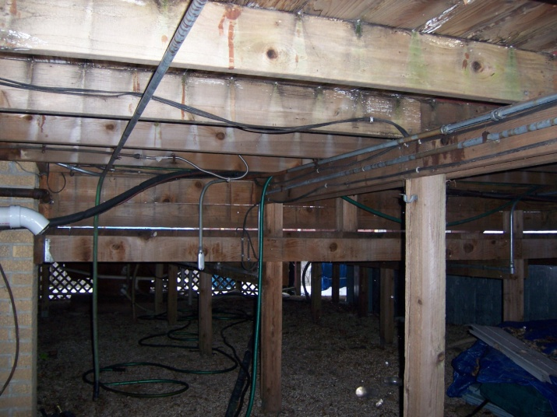
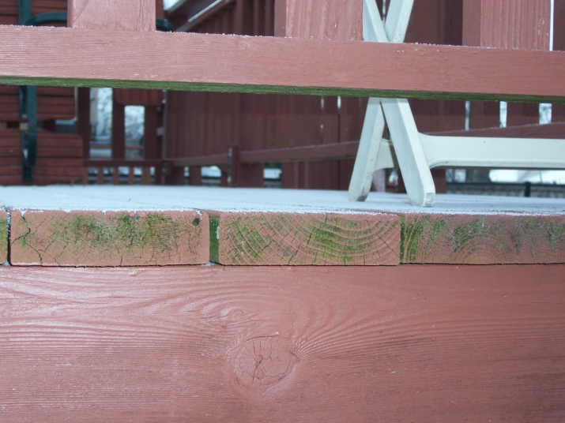

Figure 1. Mr. Pond’s Deck Frame Figure 2. Rotten Floor Boards
(by the author) (by the author)

After the visual inspection, no other major problems were evident, such as rotten floor joists, frail framing, or weak cement posts. The only repair required will be replacing the rotten floorboards. Mr. Pond’s deck will not need to be completely rebuilt, which means that a general contractor will not be needed for this project. Replacing the floorboards is a great deal easier of a project then building a new deck, which will save Mr. Pond time and money.

Client’s Needs
Before considering what material to use in the repair, it was essential to get input from Mr. Pond and see what his requirements for the repair are. This is the first step in the process to find the best method to repair his deck. Mr. Pond intends on doing the repairs by himself, so first and foremost, whatever material is selected needs to work with his existing deck frame with as little modifications as possible. The flooring has to be easy to deliver to the work site and it needs to be easy to install. Mr. Pond has a set budget of $3000. He wants the repairs to keep the deck functional as long as possible, but he only plans to live in his current residence for the next 10 years at most, so a product with a life-time guarantee is not necessary.

Different Flooring Materials
Selecting the desired material to use for the floor is the first step toward repairing the deck. There is an array of build materials to choose from such as wood, vinyl, or aluminum. Deciding what material to use is important because it will be the largest influence on the cost of repairing the deck. Depending on which material is chosen, maintenance costs for the future can also be calculated, which will also influence which material is the best choice for Mr. Pond.

Wood
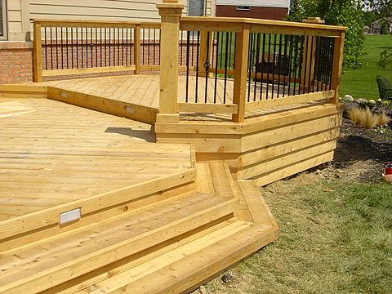
Wood is the favored material for decking. It is stable, durable, and easy to manipulate into almost any shape imaginable. Wood is environmentally friendly in that the production of wood requires about 8 times less energy than the amount to create a comparable piece of composite decking (“Real Wood”). Wood is however, susceptible to water damage and should be checked regularly. Boards that are split, cracked, or have raised nails indicate a possible problem with moisture penetration. Wood is also a porous material, like skin; and like skin, wood pores can become clogged and deteriorate. From all of the different kinds of wood that are available for decking, it was possible to narrow the number of options down to 2 because of the temperate climate of cold, snowy winters and hot, wet summers that Mr. Pond lives in and the availability of the lumber in his area.

Cedar
This type of wood is a popular choice in decks because it is very pliable, the varying grain patterns makes each deck unique and beautiful, and it has a wonderful distinctive smell. Cedar produces natural tannins that ward off insects. It doesn’t readily absorb moisture, which is what creates twisting and splitting. Cedar decking tends to lie flat and straight. It is a very durable wood, making it ideal for decks.
Figure 3. A Cedar Deck (“Cedar Deck”)

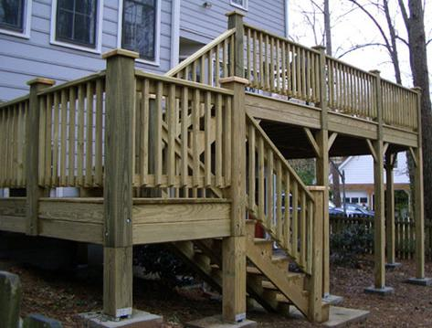
Mr. Pond’s deck was constructed out of cedar, and although it is his first choice to use in the repair, it is important to consider the other options so that the material will be the most efficient in terms of years of usage and cost to maintain.

Pressure Treated Pine
This type of wood is unique in that it is chemically treated to prevent decay and to ward of pests, as opposed to cedar which is naturally resilient. It is another durable option for flooring, but it is prone to rapid discoloration and splitting if not treated properly (“Types of Wood”).
Figure 4. A Pressure Treated Pine Deck (“Pressure Treated Pine Deck”)

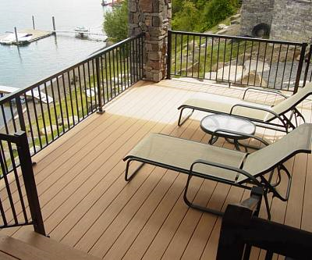
Aluminum
Another option available to Mr. Pond is aluminum flooring. This type is a modified version of siding. It is simple to install because the interlocking pieces connect together and can be screwed to the existing floor joists of the deck. This flooring option has many advantages over traditional wood flooring, the chief one being that it lasts much longer than wood. The gapless design with integrated gutters protects the underlying deck framing from the elements. The most attractive feature of this floor option is that it is practically maintenance-free aside from hosing it off when it is dirty. The only disadvantage to aluminum decking is that on the hottest of summer days, it can cause burns on bare feet.
Figure 5. An Aluminum Deck
(“Aluminum Deck”)

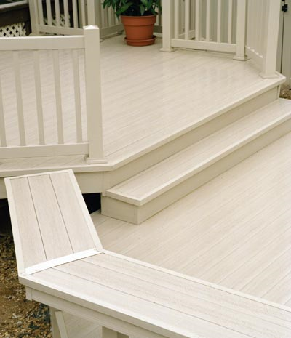
Vinyl
This flooring material is made from polyvinyl chloride (PVC), a common synthetic material that is found in thousands of products such as credit cards, drainage pipes, and raincoats. It is another popular material for decks because it is easy to install and very holds up very well against the elements. Vinyl is fire-and waterproof, which is the main advantage it has over traditional wood. Vinyl is a nonporous surface, making it weather-resistant, easy to clean, and stain resistant. It does not need to be repainted or resealed. It is an attractive option because it is maintenance-free and vinyl decking stays cool even during the hottest summer days.
Figure 6. A Vinyl Deck
(“Vinyl Decking”)

Client’s Decision
After reviewing the findings on the array of build materials, Mr. Pond decided to stay with his original plans and use cedar for the repairs. It is easy to work with, durable, and will look great for many years to come. He wants to keep the natural look of his deck, and he is especially fond of the scent of cedar. This option will fit his budget best as cedar is readily available at most home improvement stores, and transporting the lumber will not be an issue because he can fit it in the bed of his truck. He prefers cedar over pressure treated pine as cedar is naturally resistant to pests, which eliminates the human error from making wood resilient to the elements through chemical processes. Because of the nature of Mr. Pond’s job, he was able to automatically rule out the aluminum flooring. He is a siding installer, and he has noticed that the cost of aluminum siding has almost doubled in the past few years. This means that the cost of the aluminum flooring would be at least three times that of the cedar, not including the costs to cut the aluminum to the specified size and ship it to Mr. Pond. Even though vinyl flooring is practically maintenance free, Mr. Pond rejected this option because it is about twice as expensive as the cedar, again not including the costs associated with cutting it to proper dimensions and delivering it to his house.

Estimated Cost

Build Material
Mr. Pond will be able to pick up the required lumber and screws to fasten the floorboards to the joists at his local home depot. To keep the installation simple, he decided to stick with the original deck design (Figure 7.) and keep the floorboards running parallel to the wall of his home. This method will save time as opposed to other more elaborate arrangements such as having the boards set at 45° to the wall, which will require more measurements and cuts. His deck is split level (Figure 8.) and the floorboards on each level will be replaced. Measuring the current floorboards determined that 40 pieces of 16 foot long 2 by 6 boards and 76 pieces of 12 foot long 2 by 6 boards are required. The pricing for those two sizes at Home Depot are $27.89 and $21.19 respectively. Another material choice that will simplify the install is using screws to secure the floorboards to the floor joists as opposed to nailing them down. Mr. Pond does not own a nailing gun, and he does not want to invest in one just for this project. The screws that will work best with the deck are 4 inch long galvanized steel screws. They cost $53.68 for a carton where there are approximately 1000 screws, which is the amount required for the project. It is important to use galvanized steel screws instead of regular screws because the galvanized coating on the screw will protect it from the elements so that the screw does not rust and compromise its structural integrity. The total cost of materials will be $2779.72. This leaves Mr. Pond with $220.28 in his budget, which is more than enough to purchase some weather-proofing solution to seal his new floorboards.
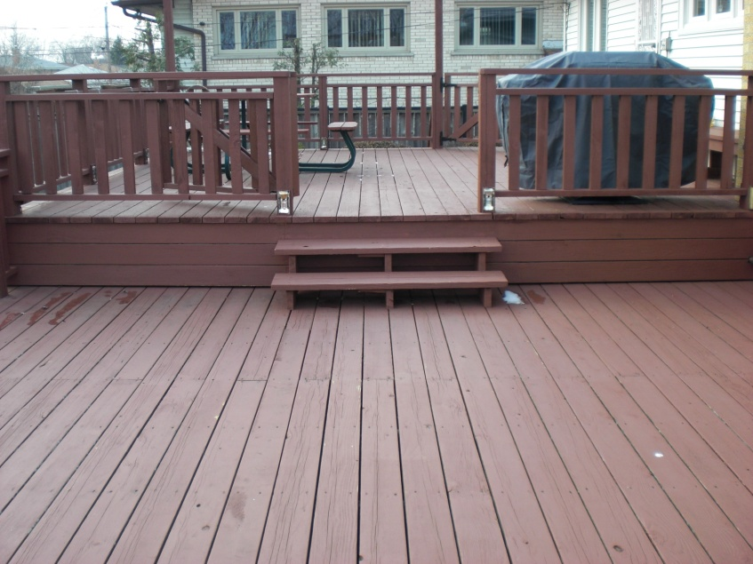
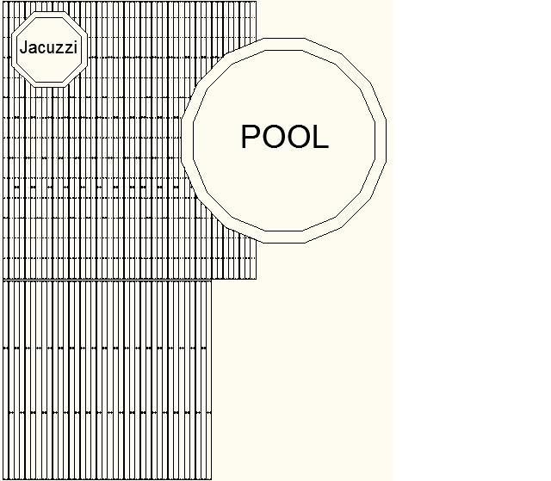

Figure 7. Over head view of the deck Figure 8. Split level view of the deck
(created by the author) (by the author)

Weather-proofing Solution
Deck stain is a weather-proofing solution that protects the decking from the elements and enhances the look of it. Mr. Pond has used the same Behr natural cedar premium transparent stain for 17 years and he wanted to add some color to the stain in order to create a contrast between his deck and house. From consulting with an expert, Ryan Nivea, from Benjamin Moore, the type of stain that will fit Mr. Pond’s needs most adequately is semi-solid stain. Semi-solid deck stains are very high in pigment with a slight transparency. They offer exceptional UV protection and better penetration that the transparent stain that Mr. Pond was using. They are very rich or dark in color due to the high pigment content, which is idea for Mr. Pond because he wants a dark red color that will contrast the white siding on his house. The price for 1 gal of the stain is $30.00. When I told Mr. Pond about this kind of stain, he went ahead and got a custom color batch mixed at Benjamin Moore and tried some on his deck. He was satisfied with the results and coated his entire deck. He stained the deck in mid-November and it has help up very well through the winter thus far. Mr. Pond’s new floorboards will require 3 gallons of stain to properly seal them. This will cost Mr. Pond an additional $90 dollars bringing the total of the project up to $2869.72.

The only maintenance that is required for the next 5 years after the repair is resealing the deck. Every season Mr. Pond will need to re-stain the floorboards, and every fifth season re-stain the deck framing, railings, stairs, and borders. It will cost Mr. Pond $90 each season he stains the floors and $180 for the seasons where is applies stain to his entire deck. This leads to the total cost for maintenance for the next five years after the repair totaling up to $540.00.

Summary
After a full inspection of Mr. Pond’s deck, it was determined that the deck is in fair condition, and the only thing that needed to be addressed was the rotten floorboards. A summary of the four available options for flooring for the repair are as follows:
Vinyl
- Easy to install
- Connects directly to existing frame
- Longer lifetime than wood
- Fire and water-proof
- Easy to clean
- Maintenance-free
- Stay cool even on the hottest summer days
- Expensive
Aluminum
- Simple to install
- Works with existing deck frame
- Lasts much longer than wood
- Gapless design shields decking from the elements
- Heats up drastically on hot days
- Expensive

- days

Pressure Treated Pine
- Chemically treated to be resilient to decay and pests
- Material is abundant
- Easy to work with
- Prone to discoloration and splitting.
Cedar
- Material is readily available
- Wonderful scent
- Naturally weather resistant
- Lies flat and straight
- Very durable

Based on his criteria, Mr. Pond chose to use cedar as his build material. It will allow him to keep a natural look to his deck, it is easy to work with, durable, and it will look great for many years to come. This option fit his budget of $3000 the best because cedar is available at home improvement stores, and transporting the lumber to the work site will not be an issue because he can fit it in the bed of his truck. The estimated costs associated with the repairs and maintenance for the next five years is summarized in the following table:

Quantity | Price per unit | Total
40 pieces of 16 foot long 2 by 6 cedar boards | $27.89 | $1115.60
76 pieces of 12 foot long 2 by 6 cedar boards | $21.19 | $1610.44
3 gallons of Benjamin Moore premium acrylic deck stain | $30.00 | $90.00
1 carton of galvanized steel screws | $53.68 | $53.68
Grand Total |  | $2869.72
Table 1. Repair Costs (created by author)

Year after Repair | Quantity | Price per unit | Total
1 | 3 gallons of Benjamin Moore premium acrylic deck stain | $30.00 | $90.00
2 | 3 gallons of Benjamin Moore premium acrylic deck stain | $30.00 | $90.00
3 | 3 gallons of Benjamin Moore premium acrylic deck stain | $30.00 | $90.00
4 | 3 gallons of Benjamin Moore premium acrylic deck stain | $30.00 | $90.00
5 | 6 gallons of Benjamin Moore premium acrylic deck stain | $30.00 | $180.00
Grand Total |  |  | $540.00
Table 2. Maintenance Costs (created by author)

Recommendations
I stand behind Mr. Pond’s decision to use cedar boards as the replacements for the rotten flooring. Given the fact that Mr. Pond plans on living at his current residence for up to 10 more years, he does not need to invest money into products such as vinyl or aluminum flooring that have a lifetime warranty. Mr. Pond plans on doing the repairs himself, so he can save money by purchasing the lumber from Home Depot and transporting it to the work site by himself. I recommend using galvanized steel screws instead of regular screws because the galvanized coating on the screw will protect it from the elements so that the screw does not rust and compromise its structural integrity. Not cutting corners and using quality materials in the repair will ensure that Mr. Pond’s deck will be safe to use for many years to come. Mr. Pond will be able to add some more years onto the life of his deck by switching the deck staining he uses from a transparent solution to a semi-solid mixture that penetrates the wood deeper, therefore providing better protection. A good timeframe to complete the project would be the month of May, which is the month before Mr. Pond opens his pool for the season. Mr. Pond does not work on the weekends, and if he manages his time properly, he can set up a plan to complete the project on the weekends. I would plan the project out in the following sequence:
- Spend the first weekend of May removing the rotten floorboards
- Purchase the materials, deliver them to the work site, and begin installing the new boards in the second weekend of May
- Finish installing the floorboards in the third weekend
- Spend the last weekend of May sealing the cedar boards with the semi-solid stain
If Mr. Pond follows this plan, he will be able to entertain guests and use his pool by the time summer begins.

Works Cited
“Aluminum Deck.” Photograph. Google Image. 7 Feb. 2010. <http://gawain.membrane.com/ aluminum_railings/crosstimber.jpg>.
“Cedar Deck.” Photograph. Google Image. 7 Feb. 2010. <http://www.cedarworks.net/gallery/ cedar%20decks/cedar%20deck%200110.jpg>.
“Decking.” Delta. 2004. 7 Jan. 2010. <http://www.deltadist.com/vinyl_decking/index.html>.
Nivea, Ryan. Benjamin Moore Sales Associate. Personal interview. Morton Grove, IL. 17 Jan. 2010.
Pond, John. Client. Personal interview. Croaker, IL. 17 Jan. 2010.

“Pressure Treated Pine Deck.” Photograph. Google Image. 7 Feb. 2010. <http:// starcraftcustombuilders.com/images/Decks/TreatedPineDeck.jpg>.

“Real Wood Decking: The Right Choice.” Southern Pine By Design. 2010. 12 Feb. 2010. <http:/www.southernpine.com/decks.choice.shtml>.

“Types of Wood.” American Deck Maintenance. 2007. 7 Jan. 2010. <http:// www.americandeck.com/wood.htm>.

“Vinyl Decking.” Photograph. Google Image. 7 Feb. 2010. <http:// www.colonialpostandfence.com/merchant2/page_photos/deck_lok_01.jpg>.

Works Consulted
“LockDry® Decking Features & Benefits.” LockDry. 2009. 7 Jan. 2010. <http://www.lockdry.com/features.htm>.
“10 Major Benefits of Galvanised Steel.” Azo Building. 2007. 7 Feb. 2010. <http://www.azobuild.com/details.asp?ArticleID=7975>.

