

|  |  |  |  |  |  |  |  |  |  |  |  |  |  |  |  |  |  |  |
| --- | --- | --- | --- | --- | --- | --- | --- | --- | --- | --- | --- | --- | --- | --- | --- | --- | --- | --- |
| Assessment Front Sheet | | | | | | | | | | | | | | | | | | |
| Course: | | | | | | | **Edexcel BTEC Level 4 HNC Diploma in Computing and Systems Development (QCF)** | | | | | | | | | | | |
| Unit: | | | | | | | **UNIT 24: NETWORKING TECHNOLOGIES** (Assignment #1) | | | | | | | | | | | |
| Subject Lecturer: | | | | | | | Satar Rahmani | | | | | | | | | | | |
| Issue Date: | | | 14/10/13 | | | | | | | Final Submission Date: | | | | | 03/02/14 | | | |
| Grading criteria attainable within this assignment✓ | | | | | | | | | | | Grading criteria met in this assignment (A/NA) | | | | | | | |
| 1.1 | 1.2 | 1.3 | 2.1 | 2.2 | | 2.3 | |  |  | |  |  |  |  | |  |  | |
| Name: | | | | | Submitted on:  Received By:  Referral Date: | | | | | | Additional Information: | | | | | | | |
|  | | | | |
|  | | | | | | | | | | | | | | | | | | |
| *Learning Outcomes* | | | | | | | *Assessment Criteria for Pass Grade* | | | | | | | | | | | *A/NA* |
| LO1  Understand networking principles | | | | | | | 1.1 discuss the benefits and constraints of different networking systems types and topologies | | | | | | | | | | |  |
| LO1  Understand networking principles | | | | | | | 1.2 evaluate the impact of current network technology, communication and standards | | | | | | | | | | |  |
| LO1  Understand networking principles | | | | | | | 1.3 discuss how protocols enable the effective utilisation of different networking systems | | | | | | | | | | |  |
| LO2  Understand networking  components | | | | | | | 2.1 discuss the role of software and hardware components | | | | | | | | | | |  |
| LO2  Understand networking  components | | | | | | | 2.2 discuss server types and selection requirement | | | | | | | | | | |  |
| LO2  Understand networking  components | | | | | | | 2.3 discuss the inter-dependence of workstation hardware with network components | | | | | | | | | | |  |

|  |  |
| --- | --- |
| **Student Declaration:** I confirm that the work I have submitted accompanying this sheet is wholly my own work and that any quotations or section of text from published or unpublished work of any other person is duly acknowledged. | Signed: Date: |

Assessor Signature: Date:

Internal Verifier Signature: Date:

(If appropriate)

|  |
| --- |
| **Pass Assessment Criteria Feedback** |

|  |  |  |
| --- | --- | --- |
| Merit descriptors | **Indicative characteristics** | **Suggestions for evidence to achieve the descriptor** |
| **(M1)**  identify and apply  strategies to find  appropriate solutions | * effective judgements have been made   • complex problems with more than one variable have been explored  • an effective approach to study and research has been applied | **The learner’s evidence shows:**   * + Evaluation and justification of the benefits and constraints of different networking systems types and topologies   + Detailed evaluation of the impact of current network technology, communication and standards.   + An effective approach and research on how protocols enable the effective utilisation of different networking systems. |
| **Feedback:** | | |
|  | | |
| **(M2)**  select/design and apply  appropriate  methods/techniques | * relevant theories and techniques have been applied * a range of methods and techniques have been applied * a range of sources of information has been used * the selection of methods and techniques/sources has been justified   the design of methods/techniques has been justified   * complex information/data has been synthesised and   processed   * appropriate learning methods/techniques have been applied | * Evaluate the role of software and hardware components that are required to build a network system for ***PC TECH*** * Evaluate server types and selection requirement * Evaluate the inter-dependence of workstation hardware with network components |
| **Feedback** | | |
|  | | |
| **(M3)**  present and  communicate  appropriate findings | the appropriate structure and approach has been used  • coherent, logical development of principles/concepts for the  intended audience  • a range of methods of presentation have been used and  technical language has been accurately used  • communication has taken place in familiar and unfamiliar  contexts  • the communication is appropriate for familiar and unfamiliar  audiences and appropriate media have been used. | Justification of the type of protocol recommended to the network system.  Evaluation of the hierarchical address and parts. |
| Feedback | | |
|  | | |

|  |
| --- |
| **Assignment #1. In this assignment you have opportunity to achieve the following criteria: 1.1, 1.2, 1.3 2.1, 2.2 and 2.3**  *You will also have to complete assignment two to achieve pass/merit/distinction in this unit.* |

|  |  |  |  |  |  |
| --- | --- | --- | --- | --- | --- |
| **Assessors comments will be inserted into your work as well as using the comments box on MOODLE. Please use these comments to make improvements to your work where necessary.**  **Colour-Coded Feedback for Electronically-Submitted Coursework**  Lecturers will use different colours to highlight text that needs improvement inside the electronically-submitted assignments. Here are the colours and their meaning:   |  | | --- | | Pink    - English error (i.e. grammar or spelling mistake) | | Green  - Knowledge error (i.e. wrong subject-related statements) | | Blue    - Irrelevant entry (i.e. not relevant to  the assessment criteria) | | Yellow – Low-quality entry (i.e. lack of detail, unclear, inaccurate, outdated or incomplete) | | Red     - Plagiarism (i.e. use of others work as your own) | |

**Specification for the network design and implementation:**

You have signed a contract to design and implement a network system for a small business called ‘***PC TECH’***, selling PC components. The manager asks you to set up and configure a client/server system for 15 staff each with one workstation.

Staff are working in a big office and sharing, three printers, folders and internet. Only one staff has the administrator access right. The rest of the staff should be given limited access right.

You’re asked by the manager to create a folder for each staff, but folders can be shared by each staff.

The owner of the folder can read, write, amend and delete files in the folder but other staff can only read the information, copy a file but are not able to amend or delete any file with the same name and in the same location. To change any file they have to save it in different location.

**Task 1: Understand networking principles**

1. **Discuss the benefits and constraints of different networking systems types and topologies**

**[1.1]**

You are acting as an ICT manager and have been asked to produce a document and explain the purpose and benefits of different network systems and topologies and suggest one that is more suitable to the case study.

You need to pay special attention to the following issues:

* + Discuss the **Purpose, benefits and limitations** of network systems and the implication of using network systems in education, society and industry.
  + Compare the **benefits and limitations** of Peer to Peer network with Client/Server network.
  + Discuss **the benefits and constraints** of:

* + - 1. Logical topologies: Ethernet and token ring,
      2. Physical topologies: star, ring, bus, mesh, tree.

1. **Evaluate the impact of current network technology, communication and standards**

**[1.2]**

Evaluate impact of current network technology that ‘*PC TECH*’ uses, considering the following:

* + - **Communication:** Explain what bandwidth and throughput mean in a network system
    - **Networking standards:**

1. conceptual models: OSI and TCP/IP,
2. standards: IEEE 802.x
3. **Discuss how protocols enable the effective utilisation of different networking systems.**

**[1.3]**

**Explain the purpose of following protocols:**

* + Routed protocols
  + Management of protocols for addressing
  + Routing protocols.

**Task 2**

1. **Discuss the role of software and hardware components**

**[ 2.1]**

* ***Hardware components*:** Explain the hardware components that are vital to build Client/Server network systems for ‘***PC TECH’***.
* ***Software components*:** Evaluate the client software, server software, client operating systems and server operating systems that are essential for ‘***PC TECH’*** network system.

**b) Discuss server types and selection requirement**

**[2.2]**

Explain the type of servers thatare essential for ‘***PC TECH’*** considering the cost, purpose and operating system requirements.

**c) Discuss the interdependence of workstation hardware with network components**

**[2.3]**

Evaluate why workstation hardware such as system bus; memory, processor, I/O devices are interdependent to network components such as switch, cables and sever.

**Task 1 - purpose, benefits and limitations**

A network system refers to a system founded on a coherent design and security architecture and that is implemented through a collection of network components that are interconnected (Larry & Bruce, 2011). Such systems have been widely utilised in the business world while in education, industry and society, efforts are underway to ensure that players in the three sectors reap the benefits that accompany the use of the systems.

The primary function of education institutions is to impart information into students. As such, network systems would serve the significant purpose of bringing information closer to students and instructors. From this, a number of benefits are realised relative to the level of networking in an institution. For a school that is fully networked, students are able to share files in a faster and more reliable manner as compared to when they are using floppy disks (Hargadon, 2013). In addition, they conveniently access central printers and all these enable them to share information and knowledge amongst themselves and between them and the instructors. Network software applications enable students to work together easily particularly on group projects. This is important considering that group projects are a common feature in learning institutions (Hargadon, 2013).

On the other hand, instructors are able to share information with their counterparts thus ensuring that they are well equipped to transfer knowledge to the students. They can also easily disseminate information especially class projects to students. However, it should also be noted that the use of network systems in education faces a number of limitations. One of the key limitations is the likely breakdown of network systems and worse still, such breakdowns may occur when online learning is in progress (Hargadon, 2013). Further, breakdowns are likely to occur at almost any point of the network system. For instance, the program-hosting server can crash thereby cutting off participants while on the other hand, internet connection can fail (Hargadon, 2013). These limitations can be blamed for the limited application of network systems in most schools.

In the society, the main purpose of using network systems is for interaction between individuals or groups of individuals. Just like in the case of education, information is easily shared. In this regard, an entire society becomes like one single location from where people communicate in a faster and effective manner. People are able to share experiences, lessons, and even take up initiatives that aim at improving the society (Larry & Bruce, 2011). On the other hand, the use of network systems in the society has a number of drawbacks. To start with, in the same manner in which valuable information is shared, information that can corrupt the morals of a society is easily disseminated. Secondly, when many members of a society are using the interconnected systems, traffic increases and this can degrade the performance of the network system particularly if it is poorly designed. Further, in a society in which resources are not equally distributed, some members may not be able to access the network systems (Larry & Bruce, 2011).

In an industry, network systems significantly improve communication and this in turn increases productivity due to coordination in task performance. Simply put, crucial information is easily disseminated. Among the most outstanding benefits emanating from the aforementioned is that employees are able to discuss ideas, enquire information, post news, and even share important links. Business contacts are also widened by use of network systems (Larry & Bruce, 2011). Further, such systems target and are able to reach a wider audience and this is crucial for an industry operating in a competitive environment. It is also possible for an industry to expand its market research by use of network system. Unfortunately, with network systems, it is possible for hackers to carry out fraud, as well as launch virus and spam attacks. The systems also make it easier for people to become victims.

**Task 1 - benefits and limitations**

Peer to peer

In this system nodes (PCs) communicate with each other directly without a server. File sharing can be done with PCs. All the PCs connect to a hub or switch. Computers are in a workgroup.

Advantages

Simple and easy to install and setup. Requires physical connectivity between each computer.

Full sharing is available

Avoid single point of failure. Failure of one node does not affect other node not working

Less implementation cost

LAN and WAN are used to link client and server so that server can provide services to the client requests. All nodes are considered as peers and thus any node can request a service from other peer or any node can provide service to other peer. A LAN peer-to-peer is similar to WAN peer-to-peer except the coverage area. WAN is considered for large area or wide area hence it stands for Wide Area Network.

Disadvantages

Administration of a single node is difficult due to the system is open and not restricted.

Less secure. Having administrator privileges create a risk of Trojan, worms and malware install.

Each PC should have standalone applications run (ex-backup systems, email )

There can be latency issues if the number of computers is high.

Less scalable

Client –server

In this system client PCs and server connect to a switch. All communication is done through server. This include user authentication, computer authentication, file sharing, permissions. With this model client request for services which are provided by the server. It firmly distinguishes the role of the server and the client.

Advantages

Scalability – Can scale with more servers and computers also deploying WAN s are supported.

More secure – Access can be controlled using permissions

Users have individual profiles

Applications install in the server can be deployed to clients with required restrictions.

Resources are dedicated to applications.

Disadvantages

Expensive – Setup of servers requires investment for hardware

If the server fails clients cannot connect.

Multiple accesses at the same time can cause delay.

For small business where you need to implement a cheap solution to cater all the services peer-to-peer is consider suitable over client-server systems. However where performance, security and for a large business client-server should be considered over peer-to-peer systems.

Cloud

Cloud system used a pool of shared hardware/software resources on demand. Cost of implementation can be high due to the requirement of high end servers and network infrastructure. Different architectures available are private, public and hybrid clouds.

Private cloud is a network/platform dedicated to a business or only one client can exist. Public cloud is where pooled shared resources are accessible over the public network. Hybrid cloud is mixed flavour of private and public cloud offering. With hybrid cloud two different cloud providers can team up to provide private and public services or organisation with private setup moves some part to public cloud (Broberg, 2011).

Advantage

Low operational cost (Pay as you go option )

Easy to setup and access

Scalable. Cloud resources are unlimited due to the elasticity.

Multiple instances can be run in shared resource pool.

Disadvantage

Require expensive hardware (Ex Thin client devices for private cloud, large servers and storage for public cloud)

Data stored in public servers is less secure.

Public cloud hardware and software customization are limited

Cluster computing

Multiple computer resources such as CPS, memory, network in a group. In cluster one, or more computers act as active and other nodes as passive mode. The required resources are managed by a storage controller or software.

Advantages

Redundancy and automatic failover

Higher performance

Scalability

Virtualized computing

In this system server running virtualization software on virtual hardware layer is used. Example - Microsoft hyper-v, VMWARE etc.

Multiple clients can connect to a virtual server for file, application email/internet access. Hardware resources are shared. Clients are known as virtual machines

Advantages

Multiple OS can be run

Dedicated connection for each virtual machine

Low cost as several connections run on one server

Disadvantage

Complex setup and management

Risk of multiple failures

Specification for the network design and implementation

Being ICT manager take Star topology with client/server setup for a system of 15 PC’s, 3 printers and 2 servers (Domain Controller with active directory). The reason I choose star topology because I can expand easily in future and while being fault tolerant. For logical topology I would use Fast Ethernet with full duplex configured on each interface to avoid any kind of collision. For providing specific services like web filtering/Email Services I would prefer to go with cloud based services for web and email services.

**Task 1 - benefits and constrains**

Today’s network system to a large extent is the convergence of Topologies and technologies. An architect has to decide where to place doors, walls, and how to manage traffic through and to the rooms while building a house similarly a network architect has to consider many physical and logical parameters while designing a network system.

Physical Topologies are the physical layout of devices, media and nodes in a network. Various topologies are -:

**Ethernet**

Traditionally bus topology is used by Ethernet which means that all hosts use the same communication line. Ethernet use RJ 45 connectors on twisted pair cables. Traditionally CSMA/CD was used to detect collisions however newer forms use full duplex Ethernet protocol in place of CSMA/CD.. Depend on the speed distance varies. Ethernet uses media such as copper to transmit and communicate in a segment. Nodes communicate using frames. Speed range from 10Mbps to 10Gbps. Protocol includes packets with the source and destination addresses.

Advantages

* Interoperability with other technologies and OSI layers
* Easy to install no need of hubs connectors
* Support for TCP/IP suite
* Inexpensive
* Immune to resistance

Disadvantages

* Relaying is difficult since the cable is continuous
* Difficult to troubleshoot
* Maximum distance 100m

**Token ring**

Computers are arranged in a ring, and a token is passed. When a customer wants to transmit data, node attaches data to token and pass. Until the other node receives the data, no communication should be done. Speeds are of 4Mbps and 16Mbps. Each segment is connected to MSAU. Cable types include UTP and STP and fiber optics.

**Advantages**

* Use CSMA/CA collision avoidance.
* Easy to deploy
* Good for temporary setup
* Not very expensive

**Disadvantages**

* Single point of failure
* Difficult to install due to cable size, thickness
* More expensive than Ethernet.
* Limited reach as short as 100 meters

**Network physical topologies**

**Star topology(Every node is connected to central device)**

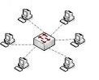

All the nodes connected to central connection point typically a switch or hub. Intercommunication between nodes is done through the central device. Node distance is maximum 100m

Advantages

* If one cable fails only one node fails.
* Failure of one node not affect other nodes
* Easy to expand and add more nodes with minimum downtime
* Can use several cable types in the topology
* Excellent Perfomance
* Support for 1024 logical network address

Disadvantages

* Failure of central device stop full network functions
* Expensive to instal
* Require more cabling than star and bus
* Single point failure, if central device failed then entire system will be down

**Ring topology( Each node is connected to a closest node to form of a circle)**

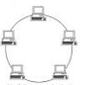

Devices connected to one another as a ring. Each node connected to the other node and last nodes connects to the first node completing the ring. Token-based communication is used.

Advantages

* Easy to install
* All computers use the same time to transmit so no resource over utilization or underutilization.
* Data is in same direction hence data can travel quickly without any bottleneck

Disadvantages

* If one node fails entire network stop work
* Require more cables than bus topology
* Difficult to identify issues
* All devices must be turned on so to complete the network
* Fault tolerance is less because total dependency is on one cable

**Bus topology(Single cable connecting all nodes)**

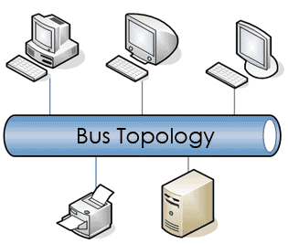

All hosts connect to a backbone cable. Nodes printer and servers connect to bus cable using connectors .T connectors or N connectors use to connect devices. Terminators are used to terminate the bus cable. In this topology signals, broadcast are received by all nodes.

Advantages

* Easy to install and expand
* Cable length required is lowest of topologies
* Not very expensive to install

Disadvantages

* Limit on the number of devices that can be connected and cable length
* If main cable fails full network stop working
* Less secure due to broadcasts
* Performance reduces when devices increase.
* Fault tolerance is minimal

**Mesh topology(Each node is interconnected with one another)**

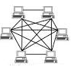

Each node is interconnected to the other node each node receives and transmits signals from other nodes. It is widely used in critical networks due to redundant paths.

Advantages

* High load and traffic
* One node fails not affect communication
* Expands can be done without downtime

Disadvantages

* Cost is high
* Maintenance is not easy (Ex routing paths, broadcast control)

**Tree(Root node is connected to more than one nodes , forming a branch like** **structure)**

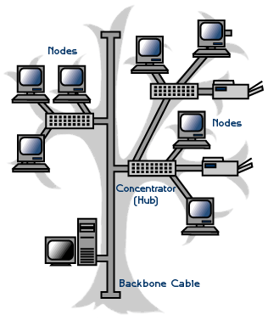

The three topology uses two or more star networks connected together. The central computers of the star networks are connected to a main bus. Thus, a tree network is a bus network of star networks.

Benefits:

1. Dedicated point-to-point wiring of each segment to the central hub
2. Network is easily scalable
3. Failure of one node will not affect other branches

Constraints:

1. Maintenance becomes difficult as more and more devices are added
2. Relies mainly on the major bus cable

**Task 1 b**

**Evaluate the impact of current network technology, communication and standards.**

Bandwidth is the capacity of data carries from one point to another at a given speed. Bandwidth depends on the media used to transmit signals and the distance. Throughput is the number of I/O requests handle for a given time.

Amount of bandwidth required is dependent on following

* Business transactions

Typical transactions in the PC-TECH can be

Downloading of price lists and brochures, internet access, email access, online chats such as Skype, voice conferencing, flyers

* Capacity of files

File capacity can be a range of several kilobytes to several hundred megabytes. PC related images and brochures have higher capacity.

* Social networking applications for marketing –requires more bandwidth
* Secure payment using payment gateways requires higher throughput and low latency
* To connect to other banking systems VPN connections required.

Bandwidth can be dividing using QOS techniques and allocate using applications use

For normal email/internet usage, less than 1Mbps bandwidth is enough. For videos streaming 2-4Mbps bandwidth is required per user. Typical email attachment can be 1-5 Mb. About hundred mails can be transmitted per day. Since the attached emails are a business requirement enough bandwidth required. Emails require 500Kbps and audio stream require 100Kbps.

Also in PC-TECH all staff is not required high bandwidth only marketing staff need high bandwidth? Accounting staff do not require high bandwidth. Also, VPN connections need high bandwidth.

For email application, upstream speed is important.

Based on the above factors a 3Mbps DSL connection can be used. However, the administrator needs to control bandwidth usage by blocking unwanted services.

For optimum throughput, a 6Mbps cable connection is recommended.

**Throughput**

Network need to operate in high throughput, and low latency to connect with other systems and to facilitate online purchasing. Use of category 6 cables can increase the throughput. Also, use of 1000Mbps switches and NICs can increase the throughput.

**Networking standards**

OSI model

OSI model is used to explain intercommunication between devices in the network

7 layers of the OSI model are as follows -

* Physical layer

Electrical signals transmit as binary through a physical medium such as cables. In PC-TECH network UTP cables, power cables are physical medium used. It`s good because using over the year or over telephone line or radio link.

* Data link layer

Layer defines form of the data on the network. Frames are used to communicate between devices in the same segment. In this layer Ethernet (IEEE802.3) Standard operates. Other tasks such as error detection and correction, sequencing is done.

Ex communication between two computers for file sharing

* Network layer

Routing is done in this layer. This layer provides internet access, and VPN tunnelling. Packets are used to communicate by establish a path.

* Transport layer

End to end delivery is done at this layer. Depend on the application reliable or unreliable transmission is done. For reliable transmission, TCP is used, and for unreliable transmission UDP is used. Applications such as DNS used UDP and internet (http), email (SMTP) use TCP. Information arrived but not completely received. No hardware and this layer however are software.

* Session layer

Establish path or channel required to transmit data. The available link is used to create a path for the given transfer

* Presentation layer

Data formatting such as encryption, compression is done here. For VPN and SSL websites encryption is required. Also for SMTP email header compression is required.

* Application layer

Transfer data between host and the end point. To access services to another layers. Application layer take care to transfer information for user: email, database, file transfer etc. Common protocols are HTTP (allow communicate between web servers to browsers), FTP (transfer files through internet) and SMTP (messaging between servers).

**TCP/IP model**

This model consists of 4 layers application (to access to another layers), transport (transmitting data between two points), internet (gives data to reach destination), network access (layer which have contains hardware.

**Comparing TCP/IP with OSI**

OSI have seven layers and TCP/IP have four layers.

Network access layer is compared to OSI layer 1 and layer 2.

Internet layer compared to OSI network layer

Transport layer compared to OSI layer transport layer

Application layer compared to OSI application, transport and session layers.

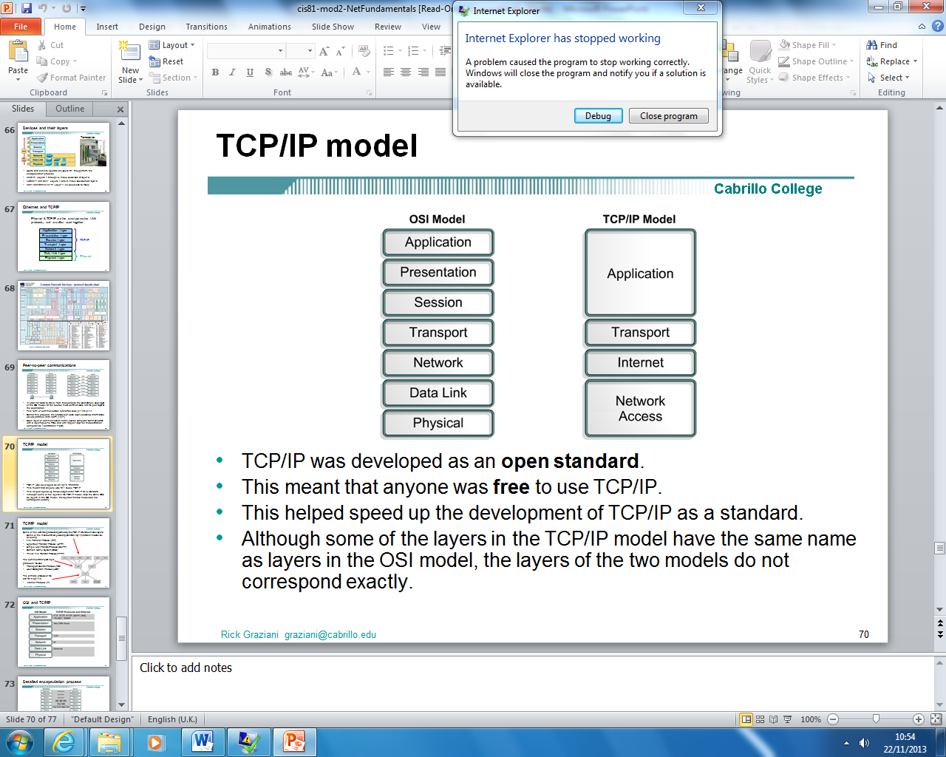

Application

Application layer of the TCP/IP model are comparable to application, presentation and session layers of OSI model. That gives way for application to constantly get access to network services. Also this layer has high levels of protocols. Major problem with layer are to use both TCP and UDP protocols.

Transport

Transport layer do deliver service for application layer. This layer action is to find all errors and fix. TCP/IP goes to solve the problem and fix however OSI don`t. Common ports and services that are on: FTP, SMTP, and POP3.

Internet

In contrast this layer perform most important role of layers architecture because routing and delivery data. It can provide through networks. IP and ARP are major protocols in his layer.

Network access

This model consist of real hardware (network card, wires etc.) . It can use various technologies and one of it is Ethernet.

Another comparison:

Differences:

TCP/IP has the presentation and session layer issues into its application layer.

TCP/IP combines the OSI data link and physical layers into one layer.

TCP/IP looks simpler for the reason that it has fewer layers.

Usually OSI networks are not built on OSI protocol however OSI model is used as a guide

Similarities:

TCP/IP and OSI both have layers.

Have application layers however they have very dissimilar services.

TCP/IP and OSI have transport and network layers

Technology packet-switched assumed

The professionals of networking essential to know both

**IEEE standards (Institute and Electronics Engineers)**

IEEE 802.3 is Ethernet. This is used in PC-TECH. IEEE802.5 token ring is not used. IEEE 802.11 is Wi-Fi, and the PC-TECH will not use WI-FI due to security and throughput. IEEE 802.11 consists of 802.11a/b/g/n. 802.11n operates at 300Mbps whereas 802.11g use 150Mbps.

**Task 1 c**

Protocols are set of standard rules use to communicate between networks and devices. Protocol consists of set of codes or messages in a special code. Protocols use ports to communicate with different layers in OSI model. Message exchange is done using protocols.

IEEE802.3 use Ethernet protocol, which used in LAN communications. Ethernet frame consists of maximum 1550 bytes data. IEEE 802.11 is Wi-Fi standard use to communicate over a wireless medium with Wi-Fi enabled devices. OSI and TCP/IP models use as a framework for protocol and operating system communication.

**Purpose of protocols**

Ethernet is used to communicate in wired medium in the LAN. WI-FI is used for roaming and mobile access.

**Routed protocols**

Routed protocols carry data.

IPv4 and IPv6 are used to denote the IP address of devices. It consists of network ID and host ID with subnet mask. Internet protocol (IP) use to communicate between hosts transmits data as bits.

FTP file transfer protocol use for upload and download files from a remote host. FTP uses port 20, 21

HTTP is used by internet web address. Website use hypertext languages such as HTML and HTTP use to transfer these files to hosts. HTTP use port 80.

SMTP – Use to send an email. Use port 25,

POP3 – receive emails using email clients pop use port 110

SSL – secure socket layer technology use to encrypt applications such as web sites and emails. Encryption is done via cryptography using certificates. SSL port 443.

**Management of protocols for addressing**

IPAM is the planning; managing and tracking of IP address space. IPV4 address space is scarce and different techniques such NAT, VLSM, subnetting. IPV6 address space is large and has enough addresses. IPAM works with DHCP. In PC-TECH, windows server works as IPAM service.

**Routing protocols**

Use to find the best path to forward packets for remote hosts. Routing protocols use algorithms to calculate best path based on different metrics. Routing protocols are built in with IOS images in routers and when routing enabled in windows servers. Routing protocols work in the network layer.

***RIP, RIPv2***

Distance vector routing protocols use hop count as metric. Full routing table forwards to the next hop. Due to this use of RIP in a large network is not recommended. Use for branch connections.

***OSPF, OSPFv3***

OSPF is a link state routing protocol where the updates are forward to neighbour routers. Use hierarchical architecture with routers connects to backbone router. Routers are placed in special management borders called areas. Area consists of several routers share common updates and routing entries. Bandwidth and delay are used as metric. Due to the architecture OSPF is best for large campus networks. Use for multiple branch connections.

***BGP***

BGP is an exterior routing protocol use by ISPs for connect internetworks belongs to different companies. BGP is a multipath routing protocol using weigh as metric. (Forouzan, A. Behrouz)

**Task 2 a**

Hardware components include active and passive equipment. Active equipment transmits data whereas passive equipment transfer signals only.

**Active equipment**

* Workstations
* Switches
* Routers
* Access points
* Printers

**Passive equipment**

* UTP cables
* Power cables
* UPS
* Patch panel

The PC-TECH network includes wired and wireless. Wired network requires following components

|  |  |  |  |  |
| --- | --- | --- | --- | --- |
|  | Hardware wired network components |  |  |  |
| **Items** | **Model** | **Specifications** |  | **Quantity** |
| UTP cables | Systimax | CAT 6 4 pair |  |  |
| RJ 45 connectors |  |  |  | 40 |
| Patch panel | Intellinet | 24 port |  | 1 |
| 19' Rack |  |  |  |  |
| cable management |  |  |  | 1 |
| CAT 6 data gate plus jack |  |  |  | 16 |
| 1m slim boot patch cords |  |  |  | 16 |
| 2m slim boot patch cords |  |  |  | 16 |
| 1U patch guide |  |  |  | 1 |
| 5 U wall mount enclosure |  |  |  | 1 |
| 24 port 10/100/1000 switch | Cisco 2960 |  |  | 1 |
| Cisco | Cisco 806 (OPTIONAL) |  |  | 1 |
| Cisco ASA 5510 firewall edition |  |  |  | 1 |
|  |  |  |  |  |
|  | Hardware wireless components |  |  |  |
| Access point | Cisco | Cisco aironet 600 |  | 1 |
|  |  |  |  |  |
|  | **Hardware components** |  |  |  |
| PCs /workstations | HP 6000 pro |  |  | 15 |
| Server | HP ML380 |  |  | 2 |
| UPS |  | 700VA |  | 15 |
| UPS |  | 1.2KVA |  | 2 |
| Network attached storage | Synology ds212j |  |  | 1 |

Cat 6 cables are used for 1000Mbps Ethernet.

**Server**

One server will be the domain controller and DNS server. Also use as a file server. Other server is used as backup domain controller.

Servers have 3 * 500 GB hard disks on RAID 5 with 8GB RAM. 64 bit processor

Servers have windows hyper v installed for virtualization.

NAS device use for data backup through network

PC s will have 500 GB hard disks with 4GB RAM. An NIC of 100/1000Mbps is used.

**Software components**

|  |  |  |  |  |
| --- | --- | --- | --- | --- |
|  | **Software components** |  |  |  |
| Item | Description |  | Quantity |  |
| Microsoft windows server 2012 R2 | Standard edition |  | 2 with CALs |  |
| Microsoft windows 8 pro |  |  | OEM |  |
| EMC AVAMAR backup |  |  |  |  |
| ESET NOD32 business edition |  |  |  |  |
| Microsoft office 2013 | Professional |  |  |  |
| Adobe suite |  |  |  |  |

**Server operating system -**

Microsoft windows server 2012 standard edition with hyper v role enabled. License required for clients CALs

***Client operating system -***

Microsoft Windows 8 Pro

# References

Hargadon, S. (2013). Educational Networking: The important role Web 2.0 will play in education. Retrieved from: <http://audio.edtechlive.com/lc/EducationalSocialNetworkingWhitepaper.pdf> on 24/10/2013

# Larry, L.P. & Bruce, S.D. (2011). *Computer Networks: A Systems Approach*. Amsterdam: Elsevier

Forouzan, A. Behrouz (2006), *Data Communications and Networking.* Tata Mc-Graw Hill Education.

Lammle Todd (2005); CCNA Routing and Switching

Dean Tamara (2011); CompTIA Network+ N10-005 In Depth

Broberg James;Cloud Computing(2011): Principles and Paradigms

Lozano Bon & Marks A. Eric(2010); Executive's Guide to Cloud Computing