Title Page

(Use your initiative to create an appropriate title page)
Course Code
Course Name
Your Name:
[Note save this word document with your Last Name/family name-Initial of your first name-student number]
{For Example: Smith-W-12345678.docx}

Executive Summary
(Simply summarise the findings of your report)
This should briefly cover your findings and may well contain figures you calculated and recommendations you make in brief.

Table of Contents (TOC)
(Use the features of Word to construct seek help if you don’t know how to do this – eg use the help function on MSWord)

Introduction

Purpose
This report was authorised by BUS106 course coordinator Dr Greg Laing, University of the Sunshine Coast. The purpose of the report is to show writer’s understanding concept of accounting in business and ability to solve questions of accounting in business, and also to complete the major assessment. The achievement of the report is 80/100 marks.

Scope
This report has incorporated course BUS106 and the book Birt, J., Chalmers, K., Byrne, S., Brooks, A. & Oliver, J. 2014, Accounting: Business Reporting for Decision Making 5th Edn., John Wiley & Sons Australia Ltd: Brisbane.

Limitations
This report is to solve provided questions, and analyses the companies income statement.

Environmental Cost Report

Categorised
This should include a figure similar to lecture slide 11 Below

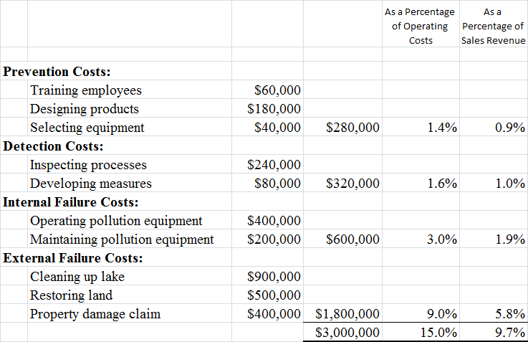
Figure 1

Strategy to Prioritise Spending

Environmental Activity Rates

3.1 Observed Data

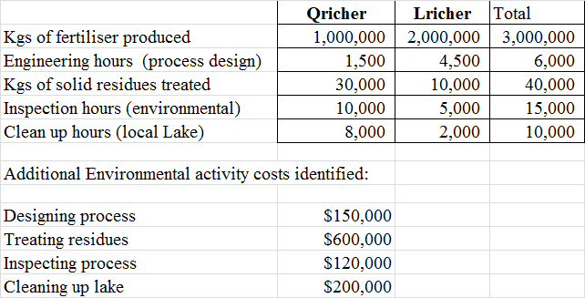
Figure 2

3.2 Inventory Analysis Stage 1

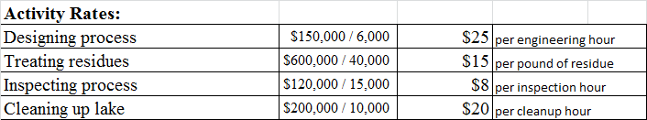
Figure 3

3.3 Inventory Analysis Stage 2

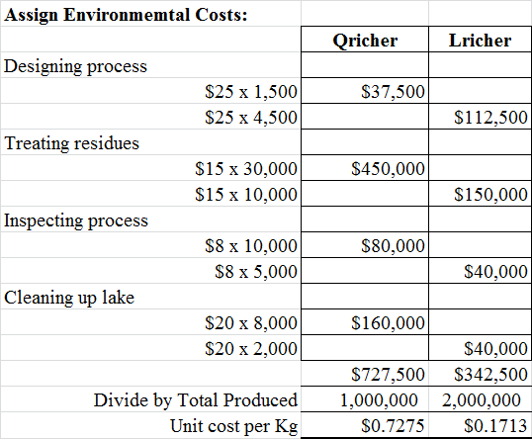
Figure 4

Additional Medical & Health Costs

Rework your figures to reflect the additional information

Special Order

5.1 Current operating capacity

5.2 Contribution Margin

5.3 Recommendation

Sustainability Index in Balanced Scorecard

References

Appendix

